**Gate Note : All Topic wise**

Below are concise yet detailed points on each of the topics. You can use these as quick revision notes for the GATE exam.

**Boolean Algebra**

1. **Definition**: A mathematical framework dealing with binary variables (0 and 1) and logical operations.
2. **Binary Variables**: Only two values exist—0 (false) and 1 (true).
3. **Basic Operations**: AND (·), OR (+), and NOT (').
4. **Commutative Laws**:
   * A+B=B+AA + B = B + A
   * A⋅B=B⋅AA \cdot B = B \cdot A
5. **Associative Laws**:
   * (A+B)+C=A+(B+C)(A + B) + C = A + (B + C)
   * (A⋅B)⋅C=A⋅(B⋅C)(A \cdot B) \cdot C = A \cdot (B \cdot C)
6. **Distributive Laws**:
   * A⋅(B+C)=A⋅B+A⋅CA \cdot (B + C) = A \cdot B + A \cdot C
   * A+(B⋅C)=(A+B)⋅(A+C)A + (B \cdot C) = (A + B) \cdot (A + C)
7. **Identity Laws**:
   * A+0=AA + 0 = A
   * A⋅1=AA \cdot 1 = A
8. **Null (Domination) Laws**:
   * A+1=1A + 1 = 1
   * A⋅0=0A \cdot 0 = 0
9. **Idempotent Laws**:
   * A+A=AA + A = A
   * A⋅A=AA \cdot A = A
10. **Complement Laws**:
    * A+A′=1A + A' = 1
    * A⋅A′=0A \cdot A' = 0
11. **Involution Law**: Double negation returns the original value: (A′)′=A(A')' = A.
12. **De Morgan’s Theorems**:
    * (A⋅B)′=A′+B′(A \cdot B)' = A' + B'
    * (A+B)′=A′⋅B′(A + B)' = A' \cdot B'
13. **Absorption Laws**:
    * A+A⋅B=AA + A \cdot B = A
    * A⋅(A+B)=AA \cdot (A + B) = A
14. **Duality Principle**: Every valid Boolean expression remains valid if AND and OR operators (and 0 and 1) are interchanged.
15. **Exclusive OR (XOR)**: Defined as A⊕B=A⋅B′+A′⋅BA \oplus B = A \cdot B' + A' \cdot B.
16. **Standard Forms**: Expressions are often written in Sum-of-Products (SOP) or Product-of-Sums (POS) forms.
17. **Logic Gate Implementation**: Direct translation of Boolean expressions to physical logic gates.
18. **Simplification Techniques**: Using algebraic manipulation, De Morgan’s laws, and identities to reduce complexity.
19. **Boolean Functions**: Mappings from a set of binary inputs to a binary output.
20. **Applications**: Fundamental to digital circuit design, switching theory, and computer algorithms.
21. **Relation to Set Theory**: Parallels exist between Boolean algebra operations and set operations (union, intersection, complement).

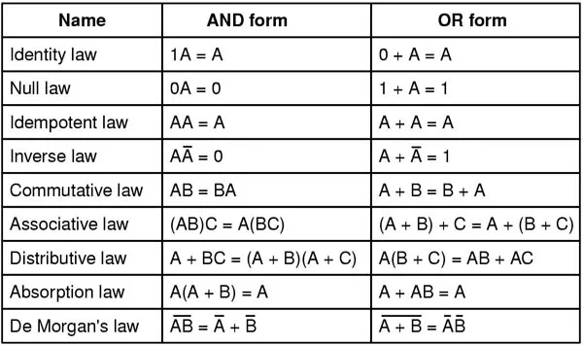

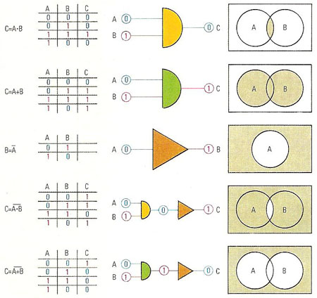

**Combinational Circuits**

1. **Definition**: Circuits where the output solely depends on the current inputs without memory elements.
2. **Basic Logic Gates**: Implemented using AND, OR, NOT, NAND, NOR, XOR, and XNOR gates.
3. **Truth Tables**: Used to describe the input-output relationship for any combinational circuit.
4. **Boolean Expression Mapping**: Circuit behavior is described using Boolean functions.
5. **Standard Forms**: Implementation via SOP (Sum-of-Products) or POS (Product-of-Sums) forms.
6. **Multiplexers (MUX)**: Circuits that select one output from multiple input signals.
7. **Demultiplexers (DEMUX)**: Circuits that route a single input to one of many outputs.
8. **Encoders**: Convert one-hot or other formats into a binary code.
9. **Decoders**: Translate binary code into a one-hot output.
10. **Adders**: Circuits like half adders and full adders perform binary addition.
11. **Subtractors**: Similar to adders but designed for binary subtraction.
12. **Comparators**: Circuits that compare two binary numbers to determine equality or magnitude.
13. **Logic Synthesis**: Process of converting Boolean expressions into a network of gates.
14. **Programmable Logic Devices (PLDs)**: Implement combinational logic in hardware using PLAs, PALs, or FPGAs.
15. **Gate Delays**: Propagation delay analysis is critical in high-speed combinational circuits.
16. **Hazard Analysis**: Identifying and mitigating static and dynamic hazards that could cause glitches.
17. **Circuit Optimization**: Techniques to reduce the number of gates, power consumption, and cost.
18. **Fan-In and Fan-Out**: Limits on the number of inputs per gate and the number of gates that can be driven.
19. **Interconnection Complexity**: Managing wiring and layout to maintain signal integrity.
20. **Applications**: Widely used in digital systems, microprocessors, and embedded systems.
21. **Scalability**: Modular design allows for building complex systems from simpler combinational blocks.
22. **Testing and Verification**: Essential for ensuring correct operation through simulation and hardware testing.

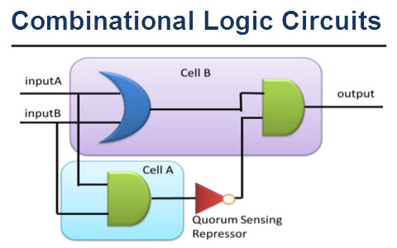

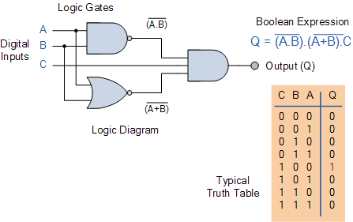

**Sequential Circuits**

1. **Definition**: Circuits whose outputs depend on both current inputs and past states (memory elements).
2. **Memory Elements**: Use of latches and flip-flops to store state information.
3. **Clocked vs. Unclocked**: Synchronous (clocked) circuits versus asynchronous (unclocked) circuits.
4. **Flip-Flops**: Basic types include SR, D, JK, and T flip-flops.
5. **Latches**: Level-sensitive devices used for temporary data storage.
6. **Timing Diagrams**: Graphical representations of how signals change over time.
7. **State Diagrams**: Illustrate the transitions between different states in a sequential circuit.
8. **Finite State Machines (FSMs)**: Abstract models such as Moore (output depends on state) and Mealy (output depends on state and input).
9. **Clock Signal**: Synchronizes state transitions; essential for proper circuit operation.
10. **Setup and Hold Times**: Critical timing requirements for reliable flip-flop operation.
11. **Race Conditions**: Occur when multiple signals change simultaneously, potentially causing unpredictable behavior.
12. **Metastability**: A state where a flip-flop may not settle to a stable 0 or 1 due to timing issues.
13. **Synchronous Design**: All state changes occur at the clock edge, simplifying timing analysis.
14. **Asynchronous Design**: State changes occur immediately with input changes, leading to potential hazards.
15. **Counters**: Sequential circuits that count pulses; examples include binary and decade counters.
16. **Registers**: Collections of flip-flops used to store multi-bit data.
17. **Shift Registers**: Circuits that move data serially or in parallel; used for data conversion.
18. **Reset and Initialization**: Ensuring circuits start in a known state.
19. **State Minimization**: Techniques to reduce the number of states in an FSM for simplicity.
20. **Sequential Circuit Design Flow**: Specification, state assignment, and logic implementation.
21. **Applications**: Essential in microprocessors, communication systems, and digital controllers.
22. **Timing Analysis**: Determining the critical path and ensuring timing constraints are met.

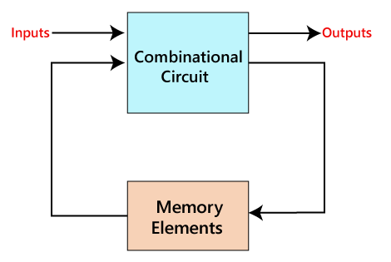

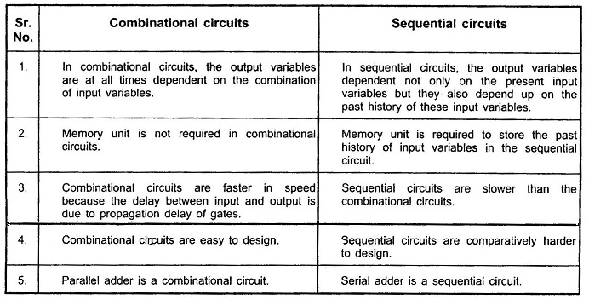

**Minimization Techniques**

1. **Purpose**: Reduce the complexity of Boolean expressions and circuit implementations.
2. **Goal**: Minimize the number of terms and literals to simplify circuits.
3. **Karnaugh Maps (K-Maps)**: A visual tool to simplify Boolean functions for up to 6 variables.
4. **Algebraic Simplification**: Applying Boolean algebra laws to reduce expressions.
5. **Quine-McCluskey Algorithm**: A systematic tabular method for minimizing Boolean functions.
6. **Don't Care Conditions**: Used in minimization when certain input combinations never occur.
7. **Sum-of-Products (SOP) Minimization**: Reducing the number of product terms.
8. **Product-of-Sums (POS) Minimization**: Simplifying expressions by reducing sum terms.
9. **Prime Implicants**: The simplest groupings in a K-map that cover one or more minterms.
10. **Essential Prime Implicants**: Must be included in the minimized function because they cover unique minterms.
11. **Consensus Theorem**: Eliminates redundant terms in Boolean expressions.
12. **Multi-Level Minimization**: Reducing complexity across multiple logic levels rather than just two.
13. **Cost Reduction**: Fewer gates and interconnections lead to lower power consumption and cost.
14. **Logic Hazards**: Minimization techniques help in identifying and reducing potential hazards.
15. **Software Tools**: CAD tools automate minimization (e.g., Espresso heuristic logic minimizer).
16. **Trade-Offs**: Balancing between minimal gate count and acceptable propagation delay.
17. **Synthesis for FPGAs/ASICs**: Optimization directly influences hardware resource utilization.
18. **Verification**: Ensuring that the minimized expression is functionally equivalent to the original.
19. **Redundancy Removal**: Eliminating unnecessary logic to streamline circuit design.
20. **Scalability Issues**: Some minimization methods may become computationally intensive as variable count increases.
21. **Impact on Reliability**: A simpler circuit tends to be more reliable and easier to test.
22. **Design Iteration**: Minimization is an iterative process, often revisited during design refinement.

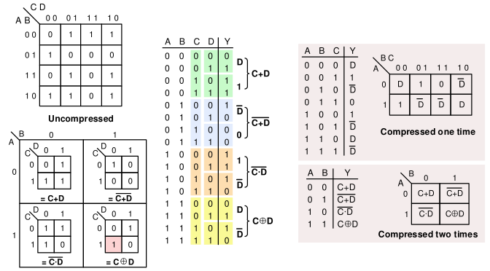

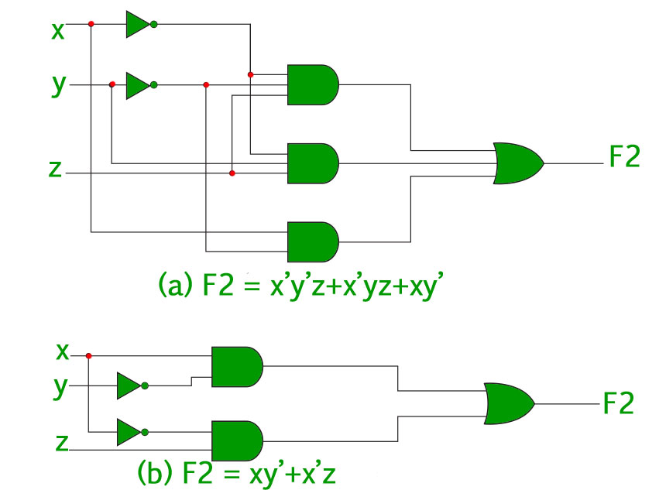

**Number Representations & Computer Arithmetic**

*(Fixed and Floating Point)*

1. **Number Systems**: Include binary, decimal, hexadecimal, and octal representations.
2. **Fixed-Point Representation**: Numbers with a fixed number of digits after (or before) the radix point.
3. **Floating-Point Representation**: Represents numbers in a form similar to scientific notation.
4. **IEEE 754 Standard**: The prevailing standard for floating-point arithmetic.
5. **Sign Bit**: Indicates the sign (positive or negative) of the number.
6. **Exponent Field**: Encodes the exponent value; often stored with a bias.
7. **Mantissa (Significand)**: Contains the significant digits of the number.
8. **Normalization**: Floating-point numbers are typically normalized so that the most significant digit is non-zero.
9. **Bias Representation**: Exponents are stored with an offset (bias) to represent both positive and negative exponents.
10. **Precision Formats**:
    * Single Precision (32-bit)
    * Double Precision (64-bit)
11. **Range and Resolution**: Floating-point numbers can represent very large and very small values with limited precision.
12. **Denormalized Numbers**: Allow representation of numbers closer to zero than the normalized format.
13. **Rounding Modes**: Common modes include round-to-nearest, round-toward-zero, round-up, and round-down.
14. **Fixed-Point Arithmetic**: Often used in embedded systems for simplicity and efficiency.
15. **Scaling Factor**: In fixed-point, a scaling factor determines the fixed position of the radix point.
16. **Arithmetic Operations**: Addition, subtraction, multiplication, and division in both fixed and floating-point formats.
17. **Overflow & Underflow**: Conditions where the result of an arithmetic operation exceeds the representable range.
18. **Error Analysis**: Floating-point arithmetic introduces rounding errors; analysis is critical for numerical stability.
19. **Conversion**: Techniques exist for converting between fixed-point and floating-point representations.
20. **Hardware Support**: CPUs and GPUs typically include dedicated arithmetic logic units (ALUs) for both types.
21. **Special Values**: Floating-point formats include representations for infinity, negative infinity, and NaN (Not a Number).
22. **Performance Considerations**: Fixed-point arithmetic can be faster and simpler in hardware, while floating-point offers greater dynamic range.
23. **Applications**: Fixed-point is common in digital signal processing, and floating-point is used in scientific computing and graphics.

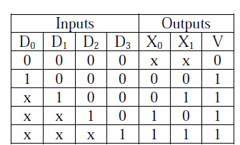

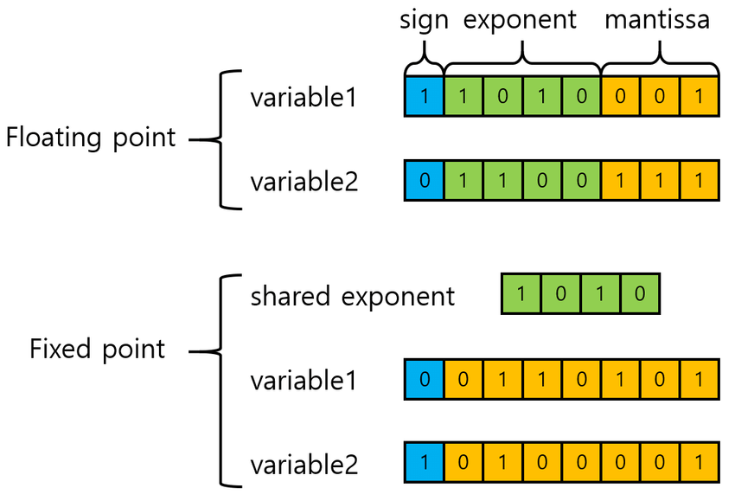

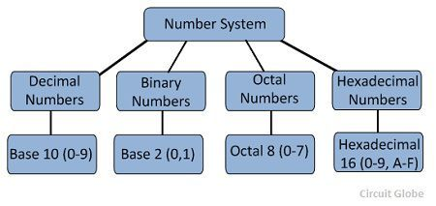

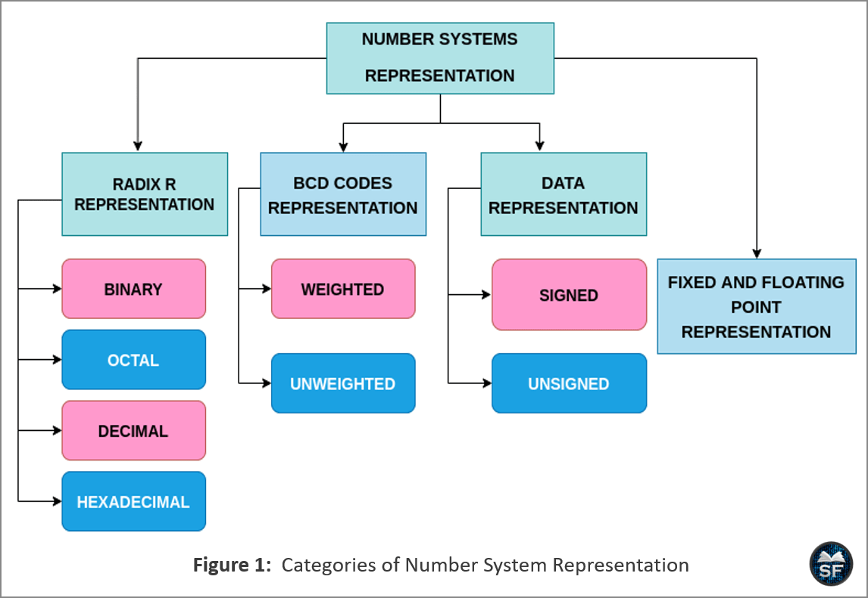

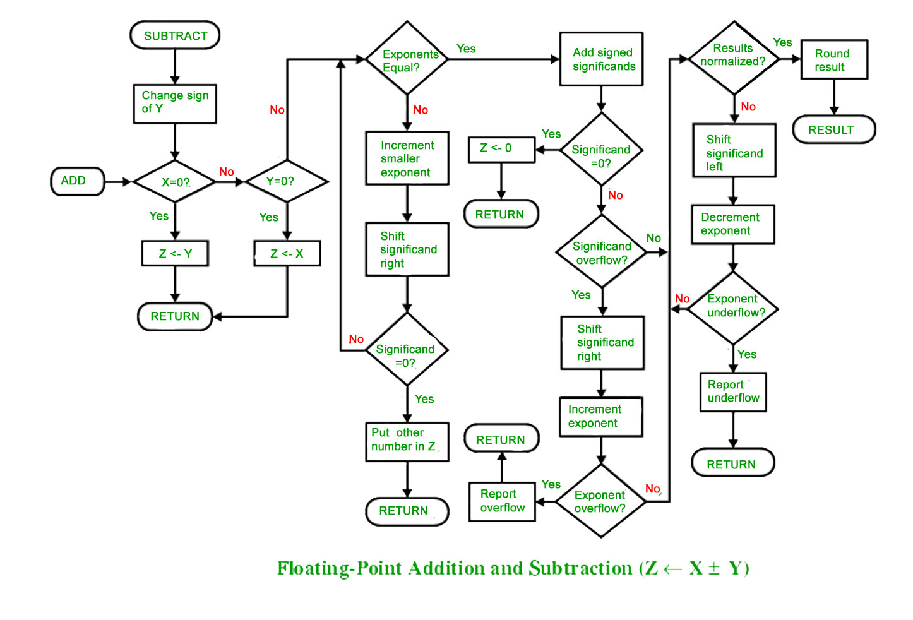

These bullet points serve as a comprehensive yet concise overview of key concepts in Digital Logic for your GATE exam. Happy studying!

Below are brief, high-level bullet points for each topic in Computer Organization and Architecture to help you prepare for the GATE exam. Each section contains 20+ points.

**1. Machine Instructions and Addressing Modes**

1. **Definition**: Machine instructions are low-level commands executed directly by the CPU.
2. **Instruction Format**: Typically consists of an opcode, operand specifiers, and addressing mode bits.
3. **Instruction Types**: Include data processing (arithmetic/logic), data transfer (load/store), and control (branch/jump) instructions.
4. **Opcode Role**: Specifies the operation to be performed.
5. **Operand Field**: Indicates the data or register(s) involved.
6. **Immediate Addressing**: Operand is directly embedded within the instruction.
7. **Direct Addressing**: The address field specifies the memory location of the operand.
8. **Indirect Addressing**: The instruction points to a memory location that contains the address of the operand.
9. **Register Addressing**: Operands are located in CPU registers, enabling faster access.
10. **Register Indirect Addressing**: A register holds the address of the operand in memory.
11. **Indexed Addressing**: Combines a base address with an index value to calculate the effective address.
12. **Relative Addressing**: Uses the current value of the program counter (PC) to calculate the address.
13. **Base-Plus-Offset Addressing**: Similar to indexed addressing but often used to access array elements.
14. **Implicit Addressing**: Operand is implied by the instruction (e.g., accumulator operations).
15. **RISC vs. CISC**: RISC architectures use simpler, fixed-length instructions with fewer addressing modes, while CISC offers multiple, more complex addressing modes.
16. **Instruction Length**: Variable-length instructions (common in CISC) vs. fixed-length (common in RISC) affect decoding complexity.
17. **Impact on Performance**: The choice of addressing mode can influence execution speed and memory access time.
18. **Decoding Complexity**: Multiple addressing modes increase the complexity of the instruction decoder.
19. **Compiler Implications**: Rich addressing modes provide flexibility but require sophisticated compiler support.
20. **Examples in Practice**: x86 architecture supports many addressing modes, whereas RISC architectures (e.g., MIPS) use a reduced set.
21. **Trade-Offs**: More addressing modes can enhance programming flexibility but may lead to increased hardware complexity.

**2. ALU, Data-path, and Control Unit**

1. **Arithmetic Logic Unit (ALU)**: Core component that performs arithmetic (add, subtract) and logical (AND, OR, NOT) operations.
2. **Basic Operations**: Includes addition, subtraction, bitwise logic, shifting, and comparisons.
3. **Data-path Definition**: The network of registers, buses, multiplexers, and ALU that performs data operations.
4. **Registers**: Fast storage elements within the CPU that hold operands and intermediate results.
5. **Buses**: Communication channels that transfer data among CPU components.
6. **Multiplexers**: Devices that select one of several input signals to forward to the ALU.
7. **Control Unit Role**: Directs the operation of the processor by generating control signals.
8. **Instruction Cycle**: Control unit manages fetch, decode, execute, memory access, and write-back stages.
9. **Hardwired Control**: Uses fixed logic circuits for control signals; fast but less flexible.
10. **Microprogrammed Control**: Uses a set of microinstructions stored in control memory; offers flexibility.
11. **Signal Timing**: Coordination between control signals and data-path elements is critical for correct operation.
12. **ALU-Register Interaction**: Data is fetched from registers, processed by the ALU, and then stored back.
13. **Control Signals**: Enable operations like selecting ALU functions, writing to registers, and memory access.
14. **Instruction Decoding**: The control unit interprets the opcode to generate the required control signals.
15. **Pipeline Integration**: Both data-path and control unit designs are critical in pipelined processors.
16. **Datapath Complexity**: Can be simple in basic CPUs or highly complex in modern superscalar designs.
17. **ALU Design Considerations**: Trade-offs between speed, area, and power consumption.
18. **Bus Arbitration**: Within the data-path, buses must be managed to avoid conflicts.
19. **Control Logic Implementation**: Can be implemented using combinational logic or sequential (state machine) logic.
20. **Impact on Performance**: Efficient design of the ALU, data-path, and control unit directly influences overall CPU speed.
21. **Scalability**: Design choices affect the ability to scale the processor for more complex operations or parallelism.

**3. Instruction Pipelining and Pipeline Hazards**

1. **Pipelining Concept**: Overlaps instruction execution by breaking the process into stages (fetch, decode, execute, etc.).
2. **Pipeline Stages**: Common stages include Instruction Fetch (IF), Instruction Decode (ID), Execute (EX), Memory Access (MEM), and Write Back (WB).
3. **Increased Throughput**: Pipelining improves instruction throughput by processing multiple instructions concurrently.
4. **Latency vs. Throughput**: While individual instruction latency may remain constant, overall throughput increases.
5. **Data Hazards**: Occur when instructions depend on results from previous instructions (e.g., RAW hazards).
6. **Types of Data Hazards**: Read-after-write (RAW), write-after-read (WAR), and write-after-write (WAW).
7. **Control Hazards**: Arise from branch instructions that change the flow of control.
8. **Structural Hazards**: Occur when hardware resources are insufficient to support concurrent operations.
9. **Pipeline Stalls**: Inserting bubbles (no-ops) to delay execution until hazards are resolved.
10. **Forwarding/Bypassing**: Techniques to use the result of a previous stage directly in a later stage to minimize stalls.
11. **Branch Prediction**: Anticipates branch outcomes to reduce control hazard delays.
12. **Delayed Branching**: A compiler/architectural technique to fill delay slots with useful instructions.
13. **Hazard Detection Units**: Hardware that detects hazards and stalls the pipeline as necessary.
14. **Pipeline Interlocks**: Automatic mechanisms that prevent data corruption by controlling instruction flow.
15. **Superscalar Architecture**: Uses multiple pipelines to execute more than one instruction per cycle.
16. **Out-of-Order Execution**: Instructions are executed in a non-sequential order to maximize resource utilization.
17. **Dynamic Scheduling**: Hardware-based reordering of instructions to minimize stalls.
18. **Speculative Execution**: Executes instructions ahead of time, based on predicted paths.
19. **Pipeline Flush**: Clearing the pipeline when a branch is mispredicted or an exception occurs.
20. **Performance Metrics**: Measured in terms of cycles per instruction (CPI) and throughput.
21. **Design Trade-Offs**: Increased pipeline depth can improve throughput but may also increase hazard frequency and complexity.

**4. Memory Hierarchy: Cache, Main Memory, and Secondary Storage**

1. **Memory Hierarchy Concept**: A layered structure to balance speed, cost, and capacity.
2. **Cache Memory**: A small, fast memory located close to the CPU to store frequently used data.
3. **Cache Levels**: Typically organized as L1 (smallest and fastest), L2, and sometimes L3 (largest and slowest).
4. **Main Memory**: Volatile memory (usually DRAM) that holds data and instructions actively used by the CPU.
5. **Secondary Storage**: Non-volatile storage (e.g., HDDs, SSDs) used for long-term data retention.
6. **Locality Principle**: Temporal and spatial locality are leveraged to improve cache performance.
7. **Cache Mapping Techniques**: Include direct-mapped, set-associative, and fully associative mapping.
8. **Cache Replacement Policies**: Algorithms such as Least Recently Used (LRU), FIFO, and Random decide which block to evict.
9. **Write Policies**: Write-through (immediate update) vs. write-back (deferred update) affect performance and consistency.
10. **Cache Coherence**: Critical in multi-core systems to maintain consistency between caches.
11. **Memory Access Time**: Varies dramatically from cache (nanoseconds) to main memory (tens of nanoseconds) to secondary storage (milliseconds).
12. **Prefetching**: Techniques that predict and load data into the cache before it is requested.
13. **Memory Controller**: Manages data flow between the CPU and main memory.
14. **Virtual Memory**: Uses disk space to extend the apparent size of RAM through paging or segmentation.
15. **Page Replacement Algorithms**: Such as LRU, optimal, and clock, manage virtual memory efficiency.
16. **Bandwidth vs. Latency**: Balancing high data transfer rates (bandwidth) with low access delays (latency).
17. **Cost Considerations**: Faster memories (cache) are more expensive per bit than slower ones (main memory, secondary storage).
18. **Hierarchy Trade-Offs**: Designers balance the speed of access against the capacity and cost.
19. **Emerging Technologies**: New memory types (e.g., 3D-stacked memory, NVRAM) are changing the memory hierarchy landscape.
20. **Impact on CPU Performance**: Cache misses and memory latency are key factors in overall system speed.
21. **System Optimization**: Effective hierarchy design minimizes bottlenecks and improves performance.

**5. I/O Interface (Interrupt and DMA Modes)**

1. **I/O Interface Role**: Provides the means for peripheral devices to communicate with the CPU.
2. **Interrupt-Driven I/O**: The device sends an interrupt signal to the CPU when it needs attention.
3. **Interrupts**: Hardware or software signals that temporarily halt CPU operations to service an event.
4. **Interrupt Vector Table**: A lookup table storing the addresses of interrupt service routines (ISRs).
5. **Priority Interrupts**: Mechanisms to assign different priority levels when multiple interrupts occur simultaneously.
6. **Maskable vs. Non-maskable Interrupts**: Maskable interrupts can be disabled, whereas non-maskable ones cannot.
7. **DMA (Direct Memory Access)**: Allows peripherals to transfer data directly to/from main memory without continuous CPU involvement.
8. **DMA Controller**: A dedicated hardware unit that manages data transfers, reducing CPU load.
9. **I/O Modes**: Distinguishes between port-mapped I/O and memory-mapped I/O.
10. **Polling vs. Interrupts**: Polling involves the CPU repeatedly checking device status, whereas interrupts are event-driven.
11. **Handshaking Signals**: Used to synchronize data transfers between the CPU and I/O devices.
12. **Bus Arbitration**: Ensures orderly access to the system bus when multiple devices request access simultaneously.
13. **DMA Transfer Modes**: Includes burst mode (transferring a block of data quickly) and cycle stealing (temporarily taking over the bus).
14. **Interrupt Latency**: The delay from the time an interrupt is generated until it is serviced.
15. **I/O Buffering**: Temporary storage used to accommodate speed differences between the CPU and peripheral devices.
16. **Software Drivers**: Programs that manage the specifics of device communication and interrupt handling.
17. **Shared Interrupts**: Multiple devices may share an interrupt line, requiring additional software logic to identify the source.
18. **Error Handling**: Both interrupts and DMA require mechanisms for detecting and handling transfer errors.
19. **Real-Time Constraints**: In real-time systems, I/O responsiveness is critical and often prioritized.
20. **Performance Impact**: Efficient I/O interfaces reduce CPU overhead, thereby improving overall system performance.
21. **System Integration**: Coordination between hardware (controllers, buses) and software (OS, drivers) is essential for reliable I/O operations.

These concise points cover the overall topics in Computer Organization and Architecture for your GATE exam. Use them as a quick revision guide, and feel free to ask if you need further clarification or additional details on any point. Happy studying!

Below is a consolidated revision guide with 20+ brief points for each topic in **Programming and Data Structures** for your GATE exam:

**1. Programming in C**

1. **Procedural Language**: C is a procedural language emphasizing function-based modularity.
2. **Standard Syntax**: Uses a clear syntax with variables, functions, loops, and conditionals.
3. **Low-Level Access**: Provides direct memory access via pointers and pointer arithmetic.
4. **Data Types**: Offers built-in types like int, float, double, char, etc.
5. **User-Defined Types**: Supports struct, union, and enum for complex data.
6. **Preprocessor Directives**: Uses #include, #define, and macros for code modularity.
7. **Standard Library**: Rich library functions (e.g., printf, scanf, malloc) for I/O and memory.
8. **Memory Management**: Uses dynamic memory allocation functions like malloc, calloc, and free.
9. **Control Structures**: Implements loops (for, while, do-while), conditional statements (if-else, switch).
10. **Compilation Process**: Code is compiled using compilers like GCC and Clang.
11. **Modularity**: Functions and header files support code reuse and organization.
12. **Portability**: C programs can be written to run on various hardware platforms.
13. **Efficient Execution**: Enables system-level programming with a focus on performance.
14. **Pointer Operations**: Allows manipulation of arrays and dynamic data structures.
15. **File I/O**: Supports file operations via standard I/O libraries.
16. **Function Recursion**: C fully supports recursion for solving complex problems.
17. **Bitwise Operations**: Provides operators for bit-level manipulation.
18. **Error Handling**: Primarily via return codes and sometimes setjmp/longjmp.
19. **Compilation Standards**: Follows ANSI C, ISO C90/C99/C11, etc.
20. **Influence**: Has influenced many modern languages and system programming paradigms.
21. **Debugging Tools**: Robust debugging support (e.g., gdb) to trace and fix errors.

**2. Recursion**

1. **Self-Referential**: A function calls itself to solve a problem.
2. **Base Case**: Essential termination condition to prevent infinite recursion.
3. **Divide and Conquer**: Breaks problems into smaller, similar subproblems.
4. **Elegant Solutions**: Often leads to simple and clear implementations.
5. **Call Stack**: Uses the program’s call stack to maintain state for each recursive call.
6. **Stack Overflows**: Deep recursion may exhaust stack space, leading to overflow.
7. **Tail Recursion**: A form that can be optimized by compilers to iterative loops.
8. **Recurrence Relations**: Helps in analyzing the time complexity of recursive algorithms.
9. **Multiple Calls**: Functions like Fibonacci may call themselves more than once per recursion.
10. **Conversion to Iteration**: Recursion can often be converted to iterative solutions.
11. **Backtracking**: Widely used in solving puzzles and exploring solution spaces.
12. **Tree Recursion**: Involves multiple recursive calls at each step.
13. **Memoization**: Caches results to avoid redundant recursive calls.
14. **Debugging Complexity**: Requires careful tracing of function calls.
15. **Space Complexity**: Additional space is used for each recursive call.
16. **Recursion vs. Iteration**: Trade-offs between clarity and performance.
17. **Common Algorithms**: Used in sorting (mergesort, quicksort) and searching (binary search).
18. **Mathematical Induction**: Recursion mirrors the principle of mathematical induction.
19. **State Preservation**: Each call retains its own set of local variables.
20. **Implementation Caution**: Must ensure each recursive step makes progress toward the base case.
21. **Functional Paradigm**: Core concept in functional programming languages.

**3. Arrays**

1. **Contiguous Storage**: Arrays store elements in continuous memory locations.
2. **Fixed Size**: In C, arrays have a fixed size defined at compile time.
3. **Homogeneous Elements**: All elements are of the same data type.
4. **Indexing**: Access elements via indices starting from 0.
5. **Random Access**: Direct access to any element in constant time, O(1).
6. **Static vs. Dynamic**: Arrays can be allocated statically or dynamically.
7. **Multi-Dimensional**: Supports 2D, 3D, or higher-dimensional arrays.
8. **Memory Efficiency**: Contiguity improves cache performance.
9. **Iteration**: Loops efficiently traverse array elements.
10. **Pointer Relationship**: The array name acts as a pointer to its first element.
11. **Initialization**: Can be initialized at declaration with fixed or computed values.
12. **Bounds Checking**: C does not perform automatic bounds checking.
13. **Use in Algorithms**: Fundamental in implementing sorting and searching algorithms.
14. **Array Decay**: In function calls, arrays decay to pointers.
15. **Variable Length Arrays (VLAs)**: Introduced in C99 for runtime-sized arrays.
16. **Memory Overhead**: Minimal, as only elements are stored with no extra pointers.
17. **Static Allocation**: Faster access but less flexible than dynamic memory.
18. **Data Structure Base**: Serves as the underlying structure for stacks, queues, etc.
19. **Contiguous Block**: Enables efficient block operations (e.g., memcpy).
20. **Limitations**: Fixed size and no built-in methods for resizing.
21. **Usage Caution**: Must manage memory to avoid buffer overflows.

**4. Stacks**

1. **LIFO Structure**: Last-In, First-Out order for data processing.
2. **Primary Operations**: Supports push (insertion) and pop (deletion).
3. **Top Operation**: Allows checking the element at the top without removal.
4. **Array Implementation**: Can be implemented using fixed-size arrays.
5. **Linked List Implementation**: Can also be implemented dynamically using linked lists.
6. **Efficient Operations**: Both push and pop operate in O(1) time.
7. **Function Call Management**: Used to manage function calls and recursion.
8. **Expression Evaluation**: Fundamental in evaluating expressions (postfix, infix).
9. **Undo Mechanism**: Implements “undo” functionality in applications.
10. **Backtracking**: Supports backtracking algorithms by reversing operations.
11. **Memory Consideration**: Can be limited by fixed size in array-based stacks.
12. **Stack Pointer**: A pointer or index tracks the top of the stack.
13. **Error Conditions**: Must handle stack underflow (empty) and overflow (full).
14. **Syntax Parsing**: Used in compilers for parsing expressions and code blocks.
15. **Control Structures**: Often underlies recursion and iterative processes.
16. **Nested Calls**: Manages nested function calls efficiently.
17. **Algorithm Design**: Used in depth-first search (DFS) and tree traversals.
18. **Data Reversal**: Helpful for reversing strings or data sequences.
19. **Resource Management**: Critical for managing limited memory resources.
20. **Debugging Tools**: Many programming debuggers use a call stack for tracking function calls.
21. **Visualization**: Often visualized as a vertical list where the top is the active element.

**5. Queues**

1. **FIFO Structure**: First-In, First-Out order ensures fairness.
2. **Primary Operations**: Enqueue (insert) and dequeue (remove).
3. **Order Preservation**: Maintains the order of processing.
4. **Array Implementation**: Can be implemented using arrays with circular buffering.
5. **Linked List Implementation**: Can be implemented using linked lists for dynamic sizing.
6. **Front and Rear Pointers**: Use pointers or indices to track start and end.
7. **O(1) Operations**: Enqueue and dequeue operations are constant time.
8. **Scheduling**: Fundamental in task scheduling and process management.
9. **Breadth-First Search (BFS)**: Used in graph traversal algorithms.
10. **Buffering**: Often used for buffering data in I/O operations.
11. **Circular Queue**: Optimizes space by wrapping around when the end is reached.
12. **Underflow**: Attempting to dequeue from an empty queue causes underflow.
13. **Overflow**: Fixed-size queues can overflow if too many elements are enqueued.
14. **Priority Queue Extension**: Can be enhanced to process elements based on priority.
15. **Double-Ended Queues (Deque)**: Allow insertion and deletion at both ends.
16. **Real-Time Systems**: Critical in ensuring timely processing of tasks.
17. **Inter-Process Communication**: Used to manage data flow between processes.
18. **Network Scheduling**: Manages packets in routers and network devices.
19. **Algorithm Integration**: Used in simulations and various algorithm designs.
20. **Resource Allocation**: Helps in managing limited resources by processing in order.
21. **Concurrency Control**: Often used with synchronization in multi-threaded environments.

**6. Linked Lists**

1. **Node-Based Structure**: Consists of nodes containing data and a pointer to the next node.
2. **Dynamic Memory**: Nodes are allocated dynamically, allowing flexible sizes.
3. **Singly Linked Lists**: Nodes point to the next node only (unidirectional).
4. **Doubly Linked Lists**: Nodes have pointers to both the next and previous nodes.
5. **Circular Linked Lists**: The last node points back to the first, forming a loop.
6. **Insertion Efficiency**: Easy insertion and deletion with pointer manipulation.
7. **No Contiguous Storage**: Unlike arrays, memory can be scattered.
8. **Traversal**: Requires sequential access from the head node.
9. **Variable Size**: Grows and shrinks dynamically without predefined limits.
10. **Memory Overhead**: Extra memory for storing pointers in each node.
11. **Implementation Basis**: Forms the basis for other data structures like stacks and queues.
12. **Head Pointer**: A pointer that marks the start of the list.
13. **Tail Pointer**: Optional pointer to the last node to optimize insertions.
14. **Search Operation**: Requires O(n) time in the worst case for finding an element.
15. **Recursive Algorithms**: Traversal and reversal can be implemented recursively.
16. **Sorted Lists**: Can be maintained in sorted order for faster searches.
17. **Insertion at Beginning**: Fast O(1) operation when adding at the head.
18. **Deletion Complexity**: Requires careful pointer updates to remove nodes.
19. **Use in Hashing**: Commonly used for collision resolution (chaining).
20. **Memory Leaks**: Must manage memory carefully to avoid leaks.
21. **Flexibility**: Ideal for applications where the size is not known in advance.

**7. Trees**

1. **Hierarchical Structure**: Represents data in a parent-child hierarchy.
2. **Root Node**: The topmost node in a tree.
3. **Child Nodes**: Each node (except the root) has one parent and can have multiple children.
4. **Leaf Nodes**: Nodes with no children.
5. **Binary Trees**: Each node has at most two children.
6. **Tree Traversal**: Methods include preorder, inorder, postorder, and level-order.
7. **Recursive Processing**: Trees are naturally processed using recursion.
8. **Hierarchical Data**: Ideal for representing structures like file systems.
9. **Insertion and Deletion**: Involves re-linking nodes while maintaining structure.
10. **Balanced vs. Unbalanced**: Balance affects search and traversal efficiency.
11. **Depth and Height**: Metrics to measure tree levels and performance.
12. **Subtrees**: Any node and its descendants form a subtree.
13. **Dynamic Structure**: Grows and shrinks as nodes are added or removed.
14. **Visualization**: Often depicted as an inverted tree diagram.
15. **Use in Decision Making**: Common in decision trees and game theory.
16. **Efficiency**: Tree operations can be efficient if the tree is balanced.
17. **Non-Linear Data**: Offers a non-linear way to store data.
18. **Memory Utilization**: Uses pointers for relationships between nodes.
19. **Search Operations**: Can be optimized for quick lookup in structured trees.
20. **Application Variety**: Used in databases, compilers, and network routing.
21. **Abstract Data Type**: Serves as the foundation for many complex structures.

**8. Binary Search Trees (BST)**

1. **Ordered Binary Tree**: Each node’s left subtree contains smaller keys, right contains larger.
2. **Efficient Search**: Average-case search, insertion, and deletion in O(log n) time.
3. **Inorder Traversal**: Yields sorted order of elements.
4. **Dynamic Set Operations**: Supports dynamic insertion and deletion.
5. **Recursive Implementation**: Commonly implemented using recursion.
6. **Node Structure**: Typically contains a key and pointers to left and right children.
7. **Search Property**: Facilitates efficient search operations by exploiting order.
8. **Insertion Logic**: New nodes are inserted by comparing keys from the root downward.
9. **Deletion Cases**: Involves handling leaf nodes, single-child, and two-child cases.
10. **Balancing Issues**: Can become skewed if elements are inserted in order.
11. **Self-Balancing Variants**: AVL and Red-Black Trees maintain balanced height.
12. **Predecessor/Successor**: Efficient retrieval of next lower or higher key.
13. **Sorted Data**: Naturally stores data in sorted order.
14. **Dynamic Updates**: Supports real-time data insertion and removal.
15. **Tree Rotations**: Used in self-balancing BSTs to maintain order.
16. **Memory Efficiency**: Uses pointers to dynamically link nodes.
17. **Deletion Complexity**: Requires careful handling to maintain BST properties.
18. **Search Efficiency**: Depends on tree height; ideally O(log n).
19. **Usage in Applications**: Widely used in databases and associative arrays.
20. **Iterative Alternatives**: Can be implemented iteratively to avoid deep recursion.
21. **Ordered Retrieval**: Ideal for in-order data retrieval and range queries.

**9. Binary Heaps**

1. **Complete Binary Tree**: Maintains a complete tree structure for efficient array storage.
2. **Heap Property**: In a min-heap, every parent is smaller than its children; vice versa for max-heaps.
3. **Priority Queue Basis**: Commonly used to implement priority queues.
4. **Array Representation**: Stored in an array with implicit parent-child relationships.
5. **Insertion (Heapify-Up)**: New elements are added at the end and bubbled up.
6. **Deletion (Heapify-Down)**: Removing the root requires restoring the heap property.
7. **O(log n) Operations**: Insertion and deletion run in logarithmic time.
8. **Access to Extremum**: Provides O(1) access to the minimum (or maximum) element.
9. **Not Fully Sorted**: The array is only partially sorted according to the heap property.
10. **Efficient Build**: Heap can be built from an unsorted array in O(n) time.
11. **Parent-Child Relationship**: Calculated using index arithmetic (e.g., parent at (i-1)/2).
12. **Dynamic Updates**: Adjusts dynamically as elements are added or removed.
13. **Use in Heap Sort**: Serves as the underlying structure for heap sort algorithms.
14. **Memory Efficiency**: No extra pointers needed; uses contiguous memory.
15. **Priority Management**: Efficiently manages elements based on priority levels.
16. **Application in Graphs**: Used in algorithms like Dijkstra’s for selecting minimum paths.
17. **Structural Guarantee**: The complete tree property ensures balanced height.
18. **Merge Operations**: Specialized heaps can support efficient merging.
19. **Visualization**: Often visualized as a nearly complete tree.
20. **Practical Implementations**: Widely implemented in standard libraries for priority queues.
21. **Use Case**: Ideal for scheduling and simulation tasks where priority ordering is needed.

**10. Graphs**

1. **Vertex-Edge Structure**: Consists of nodes (vertices) and connections (edges).
2. **Directed vs. Undirected**: Can be directed (edges have a direction) or undirected.
3. **Weighted Graphs**: Edges may carry weights for cost or distance.
4. **Representation**: Typically represented using adjacency lists or matrices.
5. **Traversal Algorithms**: Includes DFS (Depth-First Search) and BFS (Breadth-First Search).
6. **Shortest Path**: Algorithms like Dijkstra’s, Bellman-Ford, and A* compute shortest paths.
7. **Cycle Detection**: Important in identifying cycles within graphs.
8. **Connectivity**: Graphs can be connected or disconnected, with various components.
9. **Trees and DAGs**: Special graph types like trees (acyclic) and directed acyclic graphs.
10. **Graph Coloring**: Used for scheduling and resource allocation problems.
11. **Spanning Trees**: Minimum spanning tree algorithms (Kruskal’s, Prim’s) find optimal subsets.
12. **Topological Sorting**: Orders nodes in DAGs based on dependencies.
13. **Applications**: Models networks such as social networks, transportation, and communication.
14. **Complexity**: Varies with representation; sparse vs. dense graphs affect algorithm choice.
15. **Dynamic Graphs**: Vertices and edges can be added or removed dynamically.
16. **Pathfinding**: Essential in routing, mapping, and navigation applications.
17. **Data Structures**: Graphs are implemented with lists, matrices, or specialized structures.
18. **Algorithm Variants**: Many algorithms exist for different graph problems (e.g., connectivity, cycle detection).
19. **Real-World Modeling**: Applied in web page ranking, recommendation systems, and network analysis.
20. **Recursive & Iterative**: Traversal and search algorithms can use either approach.
21. **Theoretical Foundations**: Grounded in graph theory, a key area of discrete mathematics.

These concise points cover the overall topics in Programming in C and Data Structures, providing a strong revision guide for your GATE exam. Happy studying and best of luck!

Below are concise revision notes covering the overall topic of **Algorithms** for your GATE exam. Each sub-topic is summarized with 20+ key points.

**1. Searching, Sorting, and Hashing**

1. **Searching Definition**: Process of locating an element in a data structure.
2. **Linear Search**: Scans each element sequentially; O(n) time complexity.
3. **Binary Search**: Requires a sorted array; repeatedly halves the search space; O(log n) time.
4. **Interpolation & Exponential Search**: Variants that improve performance under specific conditions.
5. **Sorting Definition**: Arranging data in a specific order (ascending/descending).
6. **Comparison-Based Sorts**: Algorithms like bubble, insertion, selection sort; typically O(n²) in worst case.
7. **Efficient Sorts**: Merge sort, quicksort, and heapsort achieve O(n log n) average/worst-case performance.
8. **Non-Comparison Sorts**: Counting sort, radix sort, and bucket sort can achieve linear time under constraints.
9. **Stability in Sorting**: Stable sorts preserve the relative order of equal elements.
10. **In-Place Sorting**: Algorithms that sort without extra space (e.g., quicksort).
11. **Recursive vs. Iterative**: Some sorting/searching algorithms are naturally recursive (merge sort, binary search).
12. **Hashing Definition**: Maps keys to indices in an array (hash table) using a hash function.
13. **Hash Functions**: Must distribute keys uniformly to minimize collisions.
14. **Collision Resolution**: Techniques include chaining (linked lists) and open addressing (linear/quadratic probing, double hashing).
15. **Load Factor**: Ratio of number of stored elements to table size; critical for performance.
16. **Average-Case Performance**: Hash table lookup is O(1) on average.
17. **Worst-Case Hashing**: Can degrade to O(n) if many collisions occur.
18. **Applications**: Searching, sorting, and hashing are used in databases, indexing, caching, and more.
19. **Algorithm Trade-Offs**: Choice depends on data characteristics (size, distribution, frequency of operations).
20. **Adaptive Methods**: Some sorting algorithms (like insertion sort) perform very well on nearly sorted data.
21. **Practical Considerations**: Memory usage, ease of implementation, and constant factors also influence algorithm choice.

**2. Asymptotic Worst-Case Time and Space Complexity**

1. **Definition**: Asymptotic notation describes algorithm performance as input size (n) grows.
2. **Big-O Notation**: Expresses an upper bound on time or space complexity.
3. **Big-Omega (Ω)**: Represents a lower bound for performance.
4. **Theta (Θ)**: Denotes a tight bound when upper and lower bounds match.
5. **Worst-Case Analysis**: Evaluates the maximum resources (time/space) required.
6. **Best-Case vs. Average-Case**: Worst-case is used for guarantees, though average-case is also considered.
7. **Time Complexity Examples**: Constant O(1), logarithmic O(log n), linear O(n), linearithmic O(n log n), quadratic O(n²), exponential O(2ⁿ), etc.
8. **Space Complexity**: Measures additional memory usage aside from input storage.
9. **Ignoring Constants**: Asymptotic analysis focuses on dominant terms, ignoring constant factors and lower-order terms.
10. **Impact on Scalability**: Helps predict performance for large input sizes.
11. **Worst-Case Importance**: Critical for real-time systems and performance-critical applications.
12. **Recurrence Relations**: Used to analyze recursive algorithms.
13. **Master Theorem**: Provides a method to solve many divide-and-conquer recurrences.
14. **Amortized Analysis**: Averages worst-case performance over a sequence of operations.
15. **Algorithm Comparison**: Enables objective comparison between different algorithms.
16. **Lower Bounds**: For example, comparison-based sorting has a lower bound of Ω(n log n).
17. **Trade-Offs**: Balancing time complexity against space complexity.
18. **Worst-Case vs. Practical Performance**: Worst-case may rarely occur, but it provides an upper guarantee.
19. **Big-O for Space**: Includes both the input and extra space (auxiliary memory).
20. **Design Implications**: Helps in selecting algorithms and data structures for efficiency.
21. **Performance Modeling**: Essential for predicting how algorithms scale and behave under load.

**3. Algorithm Design Techniques: Greedy, Dynamic Programming, and Divide-and-Conquer**

1. **Design Techniques Overview**: Systematic methods to solve computational problems optimally.
2. **Greedy Algorithms**: Make the locally optimal choice at each step.
3. **Greedy Property**: Works best when local optimality leads to a global optimum.
4. **Examples (Greedy)**: Huffman coding, Kruskal’s MST, Prim’s MST, and activity selection.
5. **Advantages of Greedy**: Simple to implement and often very efficient.
6. **Limitations of Greedy**: May not always yield the globally optimal solution.
7. **Dynamic Programming (DP)**: Solves problems by breaking them into overlapping subproblems.
8. **Optimal Substructure**: A key property where an optimal solution can be built from optimal subsolutions.
9. **Memoization vs. Tabulation**: Top-down (with recursion) and bottom-up approaches to avoid redundant work.
10. **Examples (DP)**: Fibonacci sequence, knapsack problem, longest common subsequence, and matrix chain multiplication.
11. **Space-Time Trade-Offs**: DP often requires extra memory (cache/table) to store intermediate results.
12. **Divide-and-Conquer**: Recursively divides a problem into non-overlapping subproblems, solves them independently, and combines the results.
13. **Examples (Divide-and-Conquer)**: Merge sort, quicksort, and binary search.
14. **Differences with DP**: Divide-and-conquer subproblems are independent (non-overlapping), unlike DP.
15. **Recurrence Relations**: Often used to analyze divide-and-conquer algorithms.
16. **Master Theorem**: Provides a way to solve recurrences that arise in divide-and-conquer.
17. **Algorithm Selection**: The problem structure (overlapping vs. independent subproblems) guides the choice of technique.
18. **Hybrid Approaches**: Some algorithms combine techniques (e.g., using greedy choices within a DP framework).
19. **Implementation Considerations**: Greedy algorithms are generally simpler, while DP may require careful state management.
20. **Complexity Analysis**: Understanding and analyzing recurrences is critical for both DP and divide-and-conquer.
21. **Practical Applications**: These techniques are widely used in optimization, scheduling, resource allocation, and many other areas.

**4. Graph Traversals, Minimum Spanning Trees, and Shortest Paths**

1. **Graph Traversal Definition**: The process of visiting all vertices in a graph.
2. **Depth-First Search (DFS)**: Explores as far along a branch as possible before backtracking; can be implemented recursively or with a stack.
3. **Breadth-First Search (BFS)**: Explores vertices level by level using a queue.
4. **Traversal Applications**: Used for connectivity, cycle detection, and topological sorting.
5. **Time Complexity (Traversals)**: O(V + E), where V is the number of vertices and E is the number of edges.
6. **Minimum Spanning Tree (MST) Definition**: A spanning tree that connects all vertices with the minimum total edge weight.
7. **Kruskal’s Algorithm**: Greedy approach using sorting and union-find; runs in O(E log V).
8. **Prim’s Algorithm**: Builds the MST by growing from a starting vertex; similar to Dijkstra’s; O(E + V log V) with heaps.
9. **MST Applications**: Network design, clustering, and approximate solutions for NP-hard problems.
10. **Graph Representations**: Use of adjacency lists or matrices affects the performance of algorithms.
11. **Shortest Paths Problem**: Finding the minimum distance between two vertices.
12. **Dijkstra’s Algorithm**: Computes shortest paths for graphs with non-negative weights; O(E log V) with a min-heap.
13. **Bellman-Ford Algorithm**: Handles graphs with negative weights; also detects negative cycles; O(VE) time.
14. **Floyd-Warshall Algorithm**: All-pairs shortest path algorithm; O(V³) time complexity.
15. *A Search*\*: Heuristic-based algorithm for shortest paths in graphs, often used in pathfinding.
16. **Cycle Detection**: Important for identifying negative cycles (especially in Bellman-Ford).
17. **Graph Weight Considerations**: The nature of edge weights (negative, positive, zero) influences algorithm choice.
18. **Preprocessing**: Sometimes graphs are preprocessed (e.g., sorted edges) to speed up MST or shortest path algorithms.
19. **Practical Applications**: Routing protocols, urban planning, network optimization, and geographic mapping.
20. **Algorithm Adaptability**: Traversal and path algorithms can be adapted for directed, undirected, weighted, or unweighted graphs.
21. **Real-World Modeling**: Graph algorithms form the backbone of social networks, transportation systems, and computer networks.
22. **Trade-Offs in Algorithms**: Balancing between time complexity, space complexity, and implementation complexity is key.

These summarized points cover the essentials of searching, sorting, hashing, asymptotic complexity, algorithm design paradigms, and key graph algorithms. Use these for a quick review as you prepare for your GATE exam. Happy studying and best of luck!

Below is a set of concise revision points covering the overall topic of **Theory of Computation** for your GATE exam. Each section provides 20+ key points.

**1. Regular Expressions and Finite Automata**

1. **Regular Expressions Definition**: Formal language notation to describe patterns in strings.
2. **Basic Operations**: Concatenation, union (|), and Kleene star (*) form the foundation.
3. **Syntax & Semantics**: Each regex represents a set of strings (a regular language).
4. **Finite Automata Overview**: Abstract machines used to recognize regular languages.
5. **Deterministic Finite Automata (DFA)**: Have a unique next state for every state/input pair.
6. **Non-Deterministic Finite Automata (NFA)**: May have multiple possible transitions, including ϵ-moves.
7. **Equivalence of DFA and NFA**: Every NFA has an equivalent DFA (subset construction method).
8. **Conversion from Regex to NFA**: Thompson’s construction builds an NFA from a given regular expression.
9. **DFA Minimization**: Algorithms exist to reduce the number of states while preserving language acceptance.
10. **Closure Properties**: Regular languages are closed under union, concatenation, Kleene star, intersection (with regular languages), and complement.
11. **Decision Problems**: Membership, emptiness, and equivalence for regular languages are decidable.
12. **Limitations**: Regular expressions/automata cannot capture nested or recursive patterns.
13. **Formal Components of DFA**: A 5-tuple—(Q, Σ, δ, q₀, F) where Q is states, Σ is alphabet, δ is the transition function, q₀ is the start state, and F are accept states.
14. **Epsilon-Transitions in NFA**: Allow state transitions without consuming an input symbol.
15. **Subset Construction Algorithm**: Method to convert an NFA (with or without ϵ-transitions) into a DFA.
16. **Pumping Lemma for Regular Languages**: Provides a method to prove certain languages are not regular.
17. **Practical Applications**: Widely used in lexical analysis (tokenization) in compilers.
18. **Regex Engines**: Theory versus practical implementations (e.g., backtracking engines vs. DFA-based engines).
19. **Complexity**: DFAs operate in O(n) time, where n is the length of the input string.
20. **Visualization**: Finite automata are often depicted as state diagrams to illustrate transitions.
21. **Tool Support**: Tools like Lex/Flex use regular expressions and finite automata for pattern matching.

**2. Context-Free Grammars and Pushdown Automata**

1. **Context-Free Grammars (CFGs) Definition**: Consist of productions where each rule has a single non-terminal on the left-hand side.
2. **Components of CFGs**: Terminals, non-terminals, production rules, and a start symbol.
3. **Production Rules**: Define how non-terminals can be replaced by combinations of terminals and non-terminals.
4. **Derivations and Parse Trees**: Visual representations of how strings are generated from the grammar.
5. **Ambiguity in CFGs**: Occurs when a string can have more than one parse tree (multiple derivations).
6. **Normal Forms**: Chomsky Normal Form (CNF) and Greibach Normal Form (GNF) simplify parsing and proofs.
7. **Pushdown Automata (PDA) Definition**: Automata that include a stack, providing memory to handle nested structures.
8. **Acceptance Criteria**: PDAs can accept by empty stack or by reaching an accept state.
9. **Equivalence of CFGs and PDAs**: Every context-free language (CFL) can be generated by a CFG and accepted by some PDA.
10. **Non-Determinism**: PDAs are typically non-deterministic to recognize all CFLs.
11. **Stack Operations**: PDAs use push, pop, and no-operation transitions based on input symbols and the stack’s top.
12. **Grammar Derivations**: Leftmost and rightmost derivations provide systematic ways to generate strings.
13. **Parsing Techniques**: Top-down (recursive descent) and bottom-up (shift-reduce) parsing are based on CFGs.
14. **Complexity**: The membership problem for CFGs can be solved in O(n³) time (e.g., via the CYK algorithm).
15. **Applications**: CFGs are fundamental in designing programming language syntax and compilers.
16. **Closure Properties**: CFLs are closed under union and concatenation but not under intersection or complement.
17. **Examples**: The language of balanced parentheses is a classic context-free language.
18. **Limitations**: Some languages (e.g., {aⁿbⁿcⁿ}) are not context-free.
19. **Conversion to PDA**: Algorithms exist to construct a PDA from a given CFG.
20. **Importance in Computation Theory**: CFGs and PDAs illustrate how added memory (stack) extends the power of finite automata.
21. **Grammar Ambiguity Resolution**: Techniques such as left-factoring and eliminating left recursion help create unambiguous grammars.

**3. Regular and Context-Free Languages, Pumping Lemma**

1. **Regular Languages**: Languages that can be recognized by finite automata and described by regular expressions.
2. **Context-Free Languages (CFLs)**: Languages generated by CFGs and accepted by pushdown automata.
3. **Hierarchy**: Every regular language is a CFL, but not every CFL is regular.
4. **Closure Properties (Regular)**: Closed under union, intersection (with regular languages), complement, concatenation, and star.
5. **Closure Properties (CFLs)**: Closed under union, concatenation, and Kleene star; not closed under intersection or complement.
6. **Decision Problems**: Membership, emptiness, and equivalence for regular languages are decidable; similar problems for CFLs are decidable (with some restrictions).
7. **Pumping Lemma for Regular Languages**: Provides a property that all regular languages must satisfy; used to prove non-regularity.
8. **Pumping Lemma Conditions (Regular)**: For any sufficiently long string in the language, it can be divided into three parts (xyz) meeting specific conditions.
9. **Pumping Lemma for CFLs**: Similar in spirit but involves splitting strings into five parts (uvxyz) with conditions on repetition.
10. **Usage in Proofs**: Both pumping lemmas are used to show that certain languages are not regular or not context-free.
11. **Examples**: The language {aⁿbⁿ | n ≥ 0} is not regular but is context-free.
12. **Non-CFL Example**: The language {aⁿbⁿcⁿ | n ≥ 0} cannot be pumped by the CFL lemma.
13. **Hierarchy of Languages**: Part of the Chomsky hierarchy where regular languages are Type-3 and CFLs are Type-2.
14. **Expressive Power**: Regular languages cannot handle nested structures; CFLs can, thanks to their stack-based mechanisms.
15. **Proof Technique**: Pumping lemmas require choosing a long string and showing that every possible split leads to a contradiction.
16. **Limitations of Pumping Lemma**: It provides a necessary condition but not a sufficient one for language classification.
17. **Alternate Lemmas**: Ogden’s lemma extends the pumping lemma for CFLs, providing more power in some proofs.
18. **Application in Language Theory**: Helps in classifying problems and understanding the limits of automated pattern recognition.
19. **Relation to Automata**: The properties described by pumping lemmas reflect the memory constraints of finite automata and PDAs.
20. **Use in Curriculum**: Fundamental in courses on automata theory and formal languages.
21. **Implications for Design**: Understanding these lemmas assists in designing compilers and parsers that correctly handle language constructs.

**4. Turing Machines and Undecidability**

1. **Turing Machine (TM) Definition**: An abstract computational model with an infinite tape, a tape head, and a finite control.
2. **Components of a TM**: Includes a set of states, an input alphabet, a tape alphabet, a transition function, a start state, and designated accept/reject states.
3. **Infinite Tape**: Provides unlimited memory, a key feature distinguishing TMs from finite automata.
4. **Tape Head Movement**: Can move left, right, or stay in place to read/write symbols.
5. **Formal Description**: A TM is typically described as a 7-tuple (Q, Σ, Γ, δ, q₀, q_accept, q_reject).
6. **Universal Turing Machine**: Can simulate any other Turing machine; a precursor to the concept of a general-purpose computer.
7. **Church-Turing Thesis**: Posits that any algorithmic computation can be performed by a Turing machine.
8. **Decidability**: A language is decidable if there exists a TM that halts on every input, accepting those in the language.
9. **Turing-Recognizable Languages**: Also known as recursively enumerable languages; TMs may run forever on inputs not in the language.
10. **The Halting Problem**: Proven undecidable; no TM can determine for all other TMs whether they will halt on a given input.
11. **Diagonalization**: A proof technique used to show the existence of undecidable problems.
12. **Reductions**: Undecidability is often proved by reducing a known undecidable problem (like the halting problem) to another problem.
13. **Multi-Tape vs. Single-Tape**: Although multi-tape TMs can be more efficient, they are equivalent in power to single-tape TMs.
14. **Non-Deterministic Turing Machines**: Equally powerful as deterministic TMs, although they might offer efficiency benefits.
15. **Variants of TMs**: Include linear bounded automata (for context-sensitive languages) and oracle TMs.
16. **Recursion Theorem**: A fundamental result that shows TMs can incorporate their own description in computation.
17. **Rice’s Theorem**: States that any non-trivial semantic property of TMs is undecidable.
18. **Practical Implications**: Highlights the theoretical limits of what can be computed algorithmically.
19. **Historical Impact**: Turing’s work laid the foundation for modern computer science and the theory of computation.
20. **Undecidability Examples**: Problems such as the TM equivalence problem, the Post Correspondence Problem, and others are undecidable.
21. **Implications for Software**: There is no general algorithm to analyze all aspects of program behavior.
22. **Theoretical vs. Practical**: While many real-world problems are decidable, undecidability shows inherent limits in automation.

Use these bullet points as a quick revision guide to strengthen your understanding of the key concepts in Theory of Computation. Happy studying and best of luck for your GATE exam!

Below is a consolidated revision guide for **Compiler Design** covering the main topics. Each section contains 20+ brief points to help you review for your GATE exam.

**1. Lexical Analysis, Parsing, and Syntax-Directed Translation**

1. **Purpose**: Front-end of the compiler that converts source code into a structured intermediate representation.
2. **Lexical Analysis**: Scans the input string to group characters into meaningful units called tokens.
3. **Tokenization**: Identifies keywords, identifiers, constants, operators, and punctuators.
4. **Regular Expressions**: Define the patterns for tokens (e.g., digits, identifiers).
5. **Finite Automata**: Implements token recognition using deterministic (DFA) or non-deterministic (NFA) machines.
6. **Lexical Analyzer Tools**: Tools like Lex or Flex generate lexical analyzers automatically from regex specifications.
7. **Error Handling in Lexing**: Detects illegal characters and malformed tokens early in the compilation.
8. **Parsing**: Analyzes the token stream to build a parse tree based on a context-free grammar.
9. **Context-Free Grammars (CFGs)**: Define the syntax of a language using production rules.
10. **Parsing Techniques**: Includes top-down (e.g., recursive descent) and bottom-up (e.g., shift-reduce, LR parsing) approaches.
11. **Parse Trees vs. ASTs**: Full parse trees capture every syntactic detail, while Abstract Syntax Trees (ASTs) simplify the structure for translation.
12. **Ambiguity Resolution**: Uses operator precedence, associativity rules, or grammar rewriting to resolve ambiguities.
13. **Syntax-Directed Translation**: Associates semantic actions with grammar rules to perform translation during parsing.
14. **Attribute Grammars**: Enhance CFGs by adding semantic attributes (synthesized and inherited) to nodes.
15. **Translation Schemes**: Embed code snippets or actions in grammar productions to build intermediate representations.
16. **Error Recovery**: Techniques (panic mode, phrase-level recovery) allow parsing to continue after syntax errors.
17. **Table-Driven Parsing**: Uses precomputed parse tables for efficient lookups in LL or LR parsers.
18. **Semantic Analysis Kick-Off**: Syntax-directed translation lays the groundwork for subsequent semantic checks.
19. **Modularity**: Separates the lexical and syntactic analysis phases for clarity and maintainability.
20. **Integration**: The output (e.g., AST) becomes the input for intermediate code generation.
21. **Practical Examples**: Most modern compilers (like those for C/C++ and Java) follow these phases in their front-end.

**2. Runtime Environments**

1. **Definition**: The infrastructure that supports the execution of compiled programs.
2. **Activation Records**: Also called stack frames; they store local variables, parameters, return addresses, and control information.
3. **Call Stack**: A stack data structure that manages function calls and returns.
4. **Procedure Calls**: Runtime mechanisms that handle function invocation, recursion, and nested calls.
5. **Memory Organization**: Divides memory into segments such as code, stack, heap, and static data areas.
6. **Symbol Tables**: Data structures maintained at runtime to map identifiers to their attributes (e.g., type, scope, location).
7. **Parameter Passing**: Strategies such as pass-by-value, pass-by-reference, or pass-by-pointer are implemented in the environment.
8. **Stack Frame Layout**: Consists of space for local variables, arguments, saved registers, and control links.
9. **Return Address Storage**: Ensures that control returns correctly after a function call.
10. **Dynamic Memory Allocation**: Manages heap allocation and deallocation (malloc/free in C, garbage collection in higher-level languages).
11. **Static vs. Dynamic Scoping**: Determines how and when variables are resolved based on the program’s structure.
12. **Environment Records**: Hold the context for each active function or procedure.
13. **Linking**: Resolves external references and binds library routines to function calls.
14. **Register Saving/Restoration**: Preserves CPU register values across function calls.
15. **Tail Call Optimization**: An optimization that reuses stack frames for tail-recursive calls to conserve memory.
16. **Exception Handling**: Runtime support for catching and handling exceptions or errors.
17. **Dynamic Binding**: Particularly in object-oriented languages, resolves method calls at runtime.
18. **Resource Management**: Efficient handling of memory, file handles, and other resources during execution.
19. **Activation Record Lifetimes**: Managed via scope rules and lifetime of variables.
20. **Security and Isolation**: Mechanisms that protect runtime memory regions from unauthorized access.
21. **Performance Impact**: Efficient runtime environment design directly influences execution speed and resource utilization.

**3. Intermediate Code Generation**

1. **Definition**: Converts the high-level AST into a machine-independent, intermediate representation (IR).
2. **Purpose**: Facilitates machine-independent optimizations and simplifies back-end code generation.
3. **Three-Address Code**: A popular IR format where each instruction has at most three operands.
4. **Quadruples/Triples**: Representations that break instructions into operation, operands, and result.
5. **Control Flow Graphs (CFGs)**: Represent the flow of control among basic blocks for further analysis and optimization.
6. **Translation Schemes**: Systematic methods to traverse the AST and produce IR.
7. **Temporary Variables**: Introduced to hold intermediate results during expression evaluation.
8. **Operator Precedence**: Carefully managed during translation to preserve the intended order of operations.
9. **Label Generation**: Creates labels for jumps in conditional and loop constructs.
10. **Backpatching**: Technique to handle forward references in control flow (e.g., incomplete jump instructions).
11. **Machine Independence**: IR abstracts away hardware-specific details, easing retargeting.
12. **Intermediate Representation (IR) Advantages**: Enables optimizations like constant folding, dead code elimination, and common subexpression elimination.
13. **Translation of Control Structures**: Converts high-level constructs (if-else, loops, switch-case) into IR that captures their semantics.
14. **Function Calls in IR**: Represents procedure calls, parameter passing, and return values uniformly.
15. **Error Detection**: Some semantic errors may be caught during IR generation.
16. **Simplification**: IR often simplifies complex language constructs to more uniform representations.
17. **Flexibility**: Multiple IR forms (e.g., tree-based or linear code) are used based on optimization needs.
18. **Facilitates Analysis**: IR serves as the basis for subsequent data flow and control flow analyses.
19. **Optimization Interface**: Acts as a bridge between front-end parsing and back-end code generation.
20. **Design Trade-Offs**: Balances readability, optimization potential, and ease of translation.
21. **Final Code Generation**: The optimized IR is later translated into target-specific assembly or machine code.

**4. Local Optimization and Data Flow Analyses**

*(Constant Propagation, Liveness Analysis, Common Subexpression Elimination)*

1. **Local Optimization Definition**: Techniques applied within a basic block or a limited region to improve code performance.
2. **Objective**: Enhance runtime efficiency and reduce resource consumption without altering program semantics.
3. **Constant Propagation**: Replaces variables with known constant values to simplify expressions.
4. **Constant Folding**: Evaluates constant expressions at compile time, reducing runtime computation.
5. **Liveness Analysis**: Determines which variables are "live" (needed in the future) at each point in the program.
6. **Dead Code Elimination**: Removes code that computes values never used subsequently.
7. **Common Subexpression Elimination (CSE)**: Identifies and reuses repeated expressions to avoid redundant computation.
8. **Basic Blocks**: The smallest units of code with single entry and exit points; optimizations are often performed per block.
9. **Data Flow Equations**: Mathematical formulations that describe the propagation of information (e.g., variable values) through code.
10. **Control Flow Graph (CFG)**: A graph representation of basic blocks and their execution order, used for data flow analysis.
11. **Reaching Definitions**: Analysis to determine which assignments reach a particular point in the program.
12. **Use-Def Chains**: Relationships between where variables are defined and where they are used.
13. **Optimization Ordering**: Typically, constant propagation and folding are performed before more complex optimizations like CSE.
14. **Elimination of Redundant Loads**: Optimizes memory accesses by removing repeated reads of the same variable.
15. **Strength Reduction**: Replaces expensive operations (like multiplication) with equivalent but cheaper ones (like addition).
16. **Local vs. Global Optimization**: Local optimizations work within a block; global techniques extend across basic blocks.
17. **Static Single Assignment (SSA) Form**: A representation where each variable is assigned exactly once, simplifying many optimizations.
18. **Worklist Algorithms**: Iterative methods used to solve data flow equations until a fixed point is reached.
19. **Optimization Impact**: Reduces execution time and code size, contributing to overall program efficiency.
20. **Compiler Passes**: Local optimization is one of several passes in the compiler’s back-end pipeline.
21. **Performance Metrics**: Optimizations are evaluated based on improvements in runtime performance, reduced memory usage, and sometimes energy efficiency.

Use these bullet points as a quick revision guide to understand and recall key concepts in Compiler Design. Happy studying and best of luck for your GATE exam!

Below is a comprehensive revision guide with 20+ brief points for each major subtopic in **Operating Systems**. Use these as quick reminders for your GATE exam.

**1. System Calls, Processes, Threads, Inter-Process Communication, Concurrency & Synchronization**

1. **System Calls Overview**:
   * Provide the interface between user applications and the OS kernel.
2. **User Mode vs. Kernel Mode**:
   * Switching between restricted user mode and privileged kernel mode.
3. **Process Definition**:
   * An instance of a running program with its own address space.
4. **Process Life Cycle**:
   * States include new, ready, running, waiting, and terminated.
5. **Process Control Block (PCB)**:
   * Data structure storing process state, registers, and resources.
6. **Threads**:
   * Lightweight units of execution within a process that share resources.
7. **Multithreading Benefits**:
   * Enhances responsiveness and resource sharing; allows concurrent operations.
8. **Thread Models**:
   * Kernel-level vs. user-level threads, with trade-offs in scheduling and overhead.
9. **Inter-Process Communication (IPC)**:
   * Mechanisms for data exchange between processes, such as pipes, sockets, and shared memory.
10. **Pipes and FIFOs**:
    * Unidirectional channels for communication between related processes.
11. **Message Passing**:
    * Used in distributed systems; processes exchange messages explicitly.
12. **Shared Memory**:
    * Fast communication method requiring synchronization to prevent conflicts.
13. **Concurrency**:
    * Multiple processes/threads executing simultaneously, often on multi-core systems.
14. **Race Conditions**:
    * Occur when multiple threads access shared data concurrently without proper control.
15. **Critical Sections**:
    * Portions of code where shared resources are accessed and must be protected.
16. **Synchronization Primitives**:
    * Mutexes, semaphores, spinlocks, and monitors help manage access.
17. **Locking Mechanisms**:
    * Ensure mutual exclusion to prevent inconsistent states.
18. **Context Switching**:
    * Overhead incurred when the CPU switches from one process/thread to another.
19. **Interleaving of Execution**:
    * Concurrency is managed by interleaving instructions while preserving program correctness.
20. **Kernel vs. User-Level Synchronization**:
    * Different mechanisms exist based on where the synchronization logic is implemented.
21. **Performance Considerations**:
    * Balancing overhead of synchronization against the benefits of concurrency.

**2. Deadlock**

1. **Definition of Deadlock**:
   * A situation where a set of processes are permanently blocked, each waiting for a resource held by another.
2. **Necessary Conditions**:
   * Mutual Exclusion, Hold and Wait, No Preemption, and Circular Wait.
3. **Resource Allocation Graph (RAG)**:
   * A diagrammatic representation to visualize processes, resources, and potential cycles.
4. **Deadlock Detection**:
   * Algorithms that periodically check RAGs for cycles indicating deadlock.
5. **Deadlock Prevention**:
   * Techniques that structurally eliminate one or more of the necessary conditions.
6. **Deadlock Avoidance**:
   * Uses dynamic resource allocation (e.g., Banker's Algorithm) to ensure the system always remains in a safe state.
7. **Safe State**:
   * A state where there exists at least one sequence of process execution that avoids deadlock.
8. **Circular Wait Condition**:
   * Processes arranged in a circular chain where each holds at least one resource needed by the next.
9. **Resource Ordering**:
   * Imposing a global order on resource allocation to break circular waits.
10. **Starvation vs. Deadlock**:
    * Starvation is when a process never gets resources, whereas deadlock involves a cycle of waiting.
11. **Deadlock Detection Algorithms**:
    * Often involve scanning the resource allocation matrix or graph.
12. **Recovery Techniques**:
    * Methods include terminating processes, rolling back, or preempting resources.
13. **Impact on System Performance**:
    * Deadlocks can severely degrade throughput and require intervention.
14. **Timeouts**:
    * Implementing timeouts can help detect and break deadlocks.
15. **Preemptive Resource Allocation**:
    * Temporarily taking away resources from processes to resolve deadlocks.
16. **Rollback Mechanisms**:
    * Reverting processes to earlier safe states if a deadlock is detected.
17. **Deadlock in Databases**:
    * Often handled by transaction aborts and restarts.
18. **System Overhead**:
    * Deadlock detection and recovery add extra overhead to the system.
19. **Design Considerations**:
    * OS designers implement strategies to minimize or avoid deadlocks.
20. **Examples**:
    * File locking mechanisms, printer resource allocation, and other shared resource scenarios.
21. **Preventive Algorithms**:
    * Using ordered resource allocation and pre-checks to avoid deadlock conditions.

**3. CPU and I/O Scheduling**

1. **Purpose of Scheduling**:
   * To efficiently allocate CPU and I/O resources to processes.
2. **CPU Scheduling Objectives**:
   * Maximize CPU utilization, throughput, and minimize waiting and turnaround time.
3. **FCFS (First-Come-First-Served)**:
   * Processes are executed in the order they arrive; simple but may lead to long wait times.
4. **Shortest Job First (SJF)**:
   * Selects the process with the smallest execution time; minimizes average waiting time.
5. **Priority Scheduling**:
   * Processes are assigned priorities; may be preemptive, with aging techniques to prevent starvation.
6. **Round Robin (RR)**:
   * Each process gets a fixed time slice (quantum) in cyclic order; good for time-sharing systems.
7. **Multilevel Queue Scheduling**:
   * Processes are grouped into queues based on priority or type, each with its own scheduling algorithm.
8. **Context Switching Overhead**:
   * The time and resources needed to switch from one process to another.
9. **I/O Scheduling Objectives**:
   * Optimize disk access times and reduce latency for I/O operations.
10. **Elevator (SCAN) Algorithm**:
    * Moves the disk arm in one direction servicing requests and then reverses direction.
11. **C-SCAN (Circular SCAN)**:
    * Provides a more uniform wait time by treating the disk as a circular list.
12. **LOOK and C-LOOK Algorithms**:
    * Variations of SCAN that stop at the last request in one direction.
13. **Preemptive vs. Non-Preemptive**:
    * Preemptive scheduling interrupts processes to assign the CPU, while non-preemptive allows processes to run to completion.
14. **Real-Time Scheduling**:
    * Uses algorithms like Rate Monotonic and Earliest Deadline First (EDF) to meet time constraints.
15. **I/O Bound vs. CPU Bound**:
    * Different scheduling policies may be applied based on process characteristics.
16. **Scheduling Metrics**:
    * Include turnaround time, waiting time, response time, and throughput.
17. **Load Balancing in Multiprocessor Systems**:
    * Distributing processes evenly across multiple CPUs.
18. **Dispatch Latency**:
    * The delay between when a process becomes ready and when it gets the CPU.
19. **Fairness**:
    * Ensuring all processes receive an equitable share of CPU time.
20. **Hybrid Scheduling Policies**:
    * Combining different algorithms to better suit mixed workloads.
21. **I/O Scheduling in Modern OS**:
    * Often integrated with caching and buffering strategies to improve performance.

**4. Memory Management and Virtual Memory**

1. **Memory Management Purpose**:
   * Efficiently allocate and manage physical memory among processes.
2. **Contiguous Memory Allocation**:
   * Allocates a single contiguous block for a process; simple but prone to fragmentation.
3. **Non-Contiguous Memory Allocation**:
   * Techniques like paging and segmentation allow processes to use non-adjacent memory.
4. **Paging**:
   * Divides memory into fixed-size pages; eliminates external fragmentation.
5. **Page Tables**:
   * Data structures mapping virtual pages to physical frames.
6. **Translation Lookaside Buffer (TLB)**:
   * A cache used to speed up virtual address translation.
7. **Segmentation**:
   * Divides memory into segments based on logical divisions (code, data, stack); supports variable-sized memory regions.
8. **Fragmentation**:
   * Internal fragmentation: wasted space within allocated blocks; External fragmentation: unused gaps between allocations.
9. **Virtual Memory Concept**:
   * Allows execution of processes larger than physical memory by using disk space as an extension.
10. **Demand Paging**:
    * Pages are loaded into memory only when required.
11. **Swapping**:
    * The process of moving entire processes between main memory and disk.
12. **Page Replacement Algorithms**:
    * Techniques like FIFO, LRU, and Optimal to decide which page to evict.
13. **Thrashing**:
    * A condition where excessive paging leads to very poor performance.
14. **Memory Protection**:
    * Ensures that processes do not interfere with each other’s memory spaces.
15. **Address Translation**:
    * Conversion of virtual addresses to physical addresses by the MMU.
16. **Multi-Level Paging**:
    * Used in systems with large address spaces to reduce page table size.
17. **Shared Memory**:
    * Allows processes to access common memory regions for efficient IPC.
18. **Allocation Strategies**:
    * First-fit, best-fit, and worst-fit algorithms for managing free memory.
19. **Hardware Support**:
    * Memory Management Units (MMUs) perform address translation and enforce protection.
20. **Performance Metrics**:
    * Measured via page fault rates and effective memory access times.
21. **Virtual Memory Benefits**:
    * Provides process isolation, efficient memory utilization, and support for multitasking.

**5. File Systems**

1. **File System Overview**:
   * Manages how data is stored, organized, and retrieved on storage devices.
2. **File Abstraction**:
   * Files are logical entities that store data, with attributes like name, size, and permissions.
3. **Directory Structures**:
   * Organized hierarchically (tree structure) to manage files and folders.
4. **File Metadata**:
   * Information about files (creation time, modification time, access permissions).
5. **File Allocation Methods**:
   * Techniques include contiguous, linked, and indexed allocation.
6. **Contiguous Allocation**:
   * Files are stored in consecutive blocks; simple but inflexible.
7. **Linked Allocation**:
   * Files are stored as a chain of blocks linked by pointers; supports dynamic file sizes.
8. **Indexed Allocation**:
   * Uses an index block to store pointers to file data blocks; improves random access.
9. **Access Methods**:
   * Supports sequential and random access to file data.
10. **File Operations**:
    * Create, read, write, and delete operations are fundamental.
11. **File Protection**:
    * Mechanisms such as access control lists (ACLs) and permission bits restrict access.
12. **Directory Management**:
    * Structures like single-level, two-level, and tree-structured directories.
13. **Mounting**:
    * Process by which the OS makes a file system accessible to applications.
14. **Journaling**:
    * Logging changes to help recover from crashes and maintain consistency.
15. **Free Space Management**:
    * Methods such as bitmaps and linked lists to track available disk blocks.
16. **Fragmentation Issues**:
    * Internal and external fragmentation can impact performance.
17. **Buffering and Caching**:
    * Improve file access speed by keeping frequently used data in memory.
18. **Virtual File System (VFS)**:
    * An abstraction layer that allows uniform access to different file systems.
19. **Distributed File Systems**:
    * Manage files across multiple machines (e.g., NFS, AFS).
20. **Recovery and Consistency**:
    * Techniques to repair or maintain file system integrity after failures.
21. **Performance Considerations**:
    * Balancing throughput, latency, and scalability in file system design.
22. **Security**:
    * File systems implement security policies to protect data against unauthorized access.

Use these bullet points to quickly recall key concepts and details in Operating Systems. Best of luck with your GATE exam!

Below is a detailed revision guide for **Databases** covering the key topics. Each section includes 20+ concise bullet points to help you review for your GATE exam.

**1. ER-Model**

1. **Conceptual Modeling**: Provides a high-level view of real-world data and relationships.
2. **Entities**: Represent real-world objects or concepts (e.g., Student, Course).
3. **Attributes**: Describe properties of entities (e.g., Student.Name, Course.Credits).
4. **Primary Keys**: Unique identifiers for each entity instance.
5. **Composite Attributes**: Attributes that can be divided into smaller subparts (e.g., Address → Street, City, Zip).
6. **Multi-valued Attributes**: Attributes that can hold multiple values for a single entity (e.g., Phone Numbers).
7. **Derived Attributes**: Attributes calculated from other attributes (e.g., Age from Date of Birth).
8. **Relationships**: Associations between two or more entities (e.g., Enrolls, Teaches).
9. **Cardinality**: Specifies the number of instances in a relationship (one-to-one, one-to-many, many-to-many).
10. **Participation Constraints**: Total (mandatory) vs. partial (optional) participation of entities in relationships.
11. **Weak Entities**: Depend on a strong (owner) entity for their existence and identification.
12. **Identifying Relationships**: Relationships that help uniquely identify weak entities.
13. **Relationship Attributes**: Attributes that belong to a relationship rather than an individual entity.
14. **ER Diagrams**: Visual representations using symbols (e.g., rectangles for entities, diamonds for relationships).
15. **Notations**: Common notations include Chen’s, Crow’s Foot, and UML diagrams.
16. **ISA Hierarchies**: Represent generalization/specialization where a subtype inherits attributes from a supertype.
17. **Aggregation**: Treats a relationship as a higher-level entity for modeling complex relationships.
18. **Mapping to Relations**: ER models are later translated into relational schemas for implementation.
19. **Constraints**: Enforce business rules (e.g., uniqueness, participation) at the conceptual level.
20. **Semantics**: Focuses on meaning and real-world interpretation of data.
21. **Tools**: CASE tools (e.g., ERwin, Microsoft Visio) help in designing ER diagrams.

**2. Relational Model: Relational Algebra, Tuple Calculus, SQL**

1. **Relation Definition**: A table with rows (tuples) and columns (attributes) representing data.
2. **Schema vs. Instance**: Schema defines structure; instance is the current data state.
3. **Relational Algebra**: A procedural query language with a set of operations for data retrieval.
4. **Selection (σ)**: Filters rows based on specified conditions.
5. **Projection (π)**: Selects specific columns from a relation.
6. **Cartesian Product (×)**: Combines tuples from two relations to form all possible pairs.
7. **Union (∪) and Intersection (∩)**: Combine tuples from relations having the same schema.
8. **Set Difference (−)**: Returns tuples present in one relation but not in another.
9. **Join Operations**: Includes natural join, equi-join, and outer joins to combine related tuples.
10. **Division Operator**: Used for queries that ask “for all” (e.g., find students taking all courses).
11. **Tuple Calculus**: A declarative, non-procedural language using logical predicates to specify queries.
12. **Domain Calculus**: Similar to tuple calculus but variables range over attribute domains.
13. **SQL Basics**: Structured Query Language used for defining and manipulating relational databases.
14. **SELECT-FROM-WHERE**: Core SQL syntax for querying data.
15. **Subqueries and Nested Queries**: Embedding queries within queries for complex retrievals.
16. **Aggregation Functions**: COUNT, SUM, AVG, MAX, MIN perform summary calculations.
17. **GROUP BY and HAVING**: Used to group rows and filter groups based on conditions.
18. **DDL (Data Definition Language)**: Commands like CREATE, ALTER, and DROP define the database structure.
19. **DML (Data Manipulation Language)**: Commands like INSERT, UPDATE, and DELETE modify data.
20. **Views**: Virtual tables defined by queries to simplify complex operations.
21. **SQL Constraints**: Enforce data integrity (primary key, foreign key, unique, check constraints).
22. **Transaction Control**: SQL commands like COMMIT and ROLLBACK manage atomicity and consistency.

**3. Integrity Constraints and Normal Forms**

1. **Integrity Constraints**: Rules that ensure data accuracy and consistency in a database.
2. **Key Constraints**: Define primary keys and candidate keys for unique identification.
3. **Entity Integrity**: Ensures primary key values are unique and not null.
4. **Referential Integrity**: Enforces consistency between related tables using foreign keys.
5. **Domain Constraints**: Specify the permissible values for an attribute.
6. **Check Constraints**: Custom conditions that data must satisfy (e.g., age > 0).
7. **Functional Dependency**: Relationship between attributes; if A determines B, then B is functionally dependent on A.
8. **Normalization**: Process of structuring a relational database to reduce redundancy and dependency.
9. **First Normal Form (1NF)**: Ensures all attribute values are atomic (indivisible).
10. **Second Normal Form (2NF)**: Eliminates partial dependency on a composite key.
11. **Third Normal Form (3NF)**: Removes transitive dependencies to ensure non-key attributes depend only on the primary key.
12. **Boyce-Codd Normal Form (BCNF)**: A stricter version of 3NF ensuring every determinant is a candidate key.
13. **Fourth Normal Form (4NF)**: Deals with multi-valued dependencies, ensuring no non-trivial multi-valued dependency exists.
14. **Fifth Normal Form (5NF)**: Addresses join dependencies, ensuring every join dependency is implied by candidate keys.
15. **Decomposition**: Splitting relations into smaller tables to achieve a higher normal form.
16. **Lossless-Join Decomposition**: Ensures that decomposed relations can be recombined without loss of information.
17. **Dependency Preservation**: All functional dependencies are retained in the decomposed relations.
18. **Update, Insertion, and Deletion Anomalies**: Problems that normalization aims to eliminate.
19. **Denormalization**: Intentionally introducing redundancy for performance improvements while managing anomalies.
20. **Enforcement Mechanisms**: Integrity constraints can be enforced via DBMS features like triggers, constraints, and stored procedures.
21. **Normalization Trade-Offs**: Balancing between reduced redundancy and the potential need for complex joins.

**4. File Organization and Indexing (B and B+ Trees)**

1. **File Organization**: Methods for storing records on disk that affect data retrieval efficiency.
2. **Sequential File Organization**: Records stored in a sequential order; efficient for range queries.
3. **Direct/Hashed File Organization**: Records accessed via a hash function; offers constant-time access for exact matches.
4. **Indexed File Organization**: Uses indexes to speed up data access by mapping keys to record locations.
5. **Primary Index**: Built on a field that uniquely identifies records; often based on a sorted file.
6. **Secondary Index**: Built on non-unique attributes; may have multiple pointers per key.
7. **B-Tree Structure**: A balanced multi-level index that maintains sorted order and ensures logarithmic search time.
8. **Properties of B-Trees**: All leaf nodes are at the same level; nodes have a variable number of children within a predefined range.
9. **Insertion and Deletion**: Algorithms maintain tree balance and order when keys are added or removed.
10. **B+ Trees**: A variant of B-Trees where all data records are stored at the leaf level, and leaves are linked for sequential access.
11. **Internal vs. Leaf Nodes**: Internal nodes contain only keys and pointers; leaf nodes contain keys and data pointers.
12. **Range Queries**: B+ trees excel at range queries due to the linked leaf nodes.
13. **Clustered vs. Non-Clustered Indexes**: Clustered indexes determine the physical order of data, while non-clustered indexes maintain separate pointers.
14. **Indexing Overhead**: Additional storage and update cost trade off with faster query performance.
15. **Multi-Level Indexes**: Reduce the number of disk accesses by organizing indexes in multiple levels.
16. **Dynamic File Organization**: Supports variable record sizes and dynamic updates efficiently.
17. **Index Maintenance**: Insertion, deletion, and update operations require maintaining index consistency.
18. **Disk I/O Efficiency**: Indexed file organization minimizes disk accesses, crucial for large databases.
19. **Index Caching**: Frequently used index nodes can be cached in memory to improve performance.
20. **Use Cases**: Indexes are critical for quick lookups, range queries, and join operations in DBMS.
21. **Alternative Structures**: Other structures like R-trees (for spatial data) exist but B/B+ trees are most common.

**5. Transactions and Concurrency Control**

1. **Transaction Definition**: A logical unit of work that must be executed atomically.
2. **ACID Properties**: Ensure Atomicity, Consistency, Isolation, and Durability of transactions.
3. **Atomicity**: Guarantees that a transaction’s operations are all completed or none are.
4. **Consistency**: Ensures that a transaction moves the database from one valid state to another.
5. **Isolation**: Transactions run concurrently without interfering with each other’s intermediate states.
6. **Durability**: Once committed, changes persist even in the event of a system failure.
7. **Transaction States**: Active, partially committed, committed, failed, or aborted.
8. **Concurrency Control**: Mechanisms to manage simultaneous transactions and avoid conflicts.
9. **Serializability**: A correctness criterion ensuring that concurrent transactions produce the same results as some serial execution.
10. **Conflict Serializability**: Based on ordering conflicting operations (read/write) to avoid anomalies.
11. **Lock-Based Protocols**: Use shared and exclusive locks to control concurrent access.
12. **Two-Phase Locking (2PL)**: Ensures serializability by having a growing and a shrinking phase for locks.
13. **Deadlock Detection/Prevention**: Techniques to detect circular wait conditions or prevent them via timeouts or ordering.
14. **Timestamp Ordering**: Assigns timestamps to transactions to order their operations.
15. **Optimistic Concurrency Control**: Assumes conflicts are rare and checks for conflicts only at commit time.
16. **Multi-Version Concurrency Control (MVCC)**: Maintains multiple versions of data items to allow concurrent reads and writes.
17. **Isolation Levels**: Define the degree of isolation (Read Uncommitted, Read Committed, Repeatable Read, Serializable).
18. **Lock Granularity**: Fine-grained (row-level) vs. coarse-grained (table-level) locking impacts concurrency and performance.
19. **Commit Protocols**: Two-phase commit (2PC) in distributed environments ensures all-or-nothing across sites.
20. **Logging and Recovery**: Write-ahead logging and checkpoints support recovery in case of transaction failures.
21. **Rollback Mechanisms**: Allow transactions to be undone to preserve database consistency.
22. **Performance Trade-offs**: Balancing high throughput with the overhead of ensuring ACID properties.

Use these bullet points as a quick revision guide to reinforce key concepts and details in Databases for your GATE exam. Happy studying and best of luck!

Below is a comprehensive revision guide for **Computer Networks** covering the overall topic for your GATE exam. Each section contains 20+ concise bullet points to help you review.

**1. Layering Concepts, OSI & TCP/IP, and Switching Techniques**

1. **Layered Architecture**: Organizes network functions into layers, promoting modularity and standard interfaces.
2. **OSI Model**: Consists of 7 layers—Physical, Data Link, Network, Transport, Session, Presentation, and Application.
3. **TCP/IP Protocol Stack**: Typically has 4 layers—Link, Internet, Transport, and Application; it combines some OSI layers.
4. **Layer Functionality**: Each layer provides services to the layer above and uses services of the layer below.
5. **Encapsulation**: Data is wrapped with protocol information at each layer (headers and trailers) during transmission.
6. **Decapsulation**: At the receiving end, each layer removes its respective header/trailer to retrieve the original data.
7. **Advantages of Layering**: Simplifies design, troubleshooting, and protocol development; enables independent evolution.
8. **Packet Switching**: Data is divided into packets that are individually routed over shared network links.
9. **Circuit Switching**: A dedicated communication path is established between sender and receiver for the duration of a session.
10. **Virtual Circuit Switching**: Combines packet switching’s efficiency with a pre-established logical route (e.g., ATM, MPLS).
11. **Statistical Multiplexing**: Packet switching dynamically shares network capacity among multiple users.
12. **Dedicated Resources**: In circuit switching, resources are reserved, ensuring predictable performance but lower efficiency.
13. **Virtual Circuits**: Provide a guaranteed path (logical connection) while still sharing underlying resources.
14. **Flexibility**: Packet switching adapts dynamically to traffic loads and network failures.
15. **Quality of Service (QoS)**: Virtual circuits can offer QoS guarantees for latency-sensitive applications.
16. **Protocol Hierarchy**: OSI is a reference model; TCP/IP is the practical implementation used in the Internet.
17. **Addressing & Routing**: Layering helps separate addressing (network layer) from error detection (data link layer).
18. **Modularity Benefits**: Allows independent development and upgrading of each layer without affecting the others.
19. **Switching Efficiency**: Packet switching improves network utilization; circuit switching minimizes delay in predictable scenarios.
20. **Implementation Examples**: Telephone networks (circuit switching), the Internet (packet switching), and ATM networks (virtual circuits).
21. **Inter-layer Communication**: Service Access Points (SAPs) provide the interface between layers.

**2. Data Link Layer: Framing, Error Detection, MAC, and Ethernet Bridging**

1. **Framing**: The process of dividing a bit stream into discrete frames for transmission.
2. **Frame Delimitation**: Methods include special flag sequences, byte stuffing, and bit stuffing.
3. **Frame Structure**: Typically includes a header (addresses and control info), payload, and trailer (error-checking).
4. **Error Detection**: Techniques such as parity bits, checksums, and Cyclic Redundancy Check (CRC) are used.
5. **Frame Check Sequence (FCS)**: A field in the trailer for error detection using CRC.
6. **Medium Access Control (MAC)**: Coordinates access to the shared physical medium.
7. **MAC Protocols**: Include CSMA/CD (Carrier Sense Multiple Access with Collision Detection) for wired Ethernet and CSMA/CA for wireless.
8. **Collision Handling**: In Ethernet, collisions are detected and frames are retransmitted after random backoffs.
9. **MAC Addresses**: Unique hardware addresses assigned to network interface controllers (NICs).
10. **Ethernet Standards**: Define frame formats, speeds (10/100/1000 Mbps, etc.), and wiring standards.
11. **Ethernet Bridging**: Devices like bridges and switches connect LAN segments and reduce collision domains.
12. **Switching vs. Bridging**: Both operate at the data link layer; switches make forwarding decisions based on MAC addresses.
13. **VLAN Tagging**: Ethernet frames can include VLAN tags (IEEE 802.1Q) to segregate traffic.
14. **Flow Control**: Mechanisms (e.g., pause frames) prevent buffer overflow between connected devices.
15. **Link Layer Addressing**: Used for intra-network communication, distinct from IP addressing.
16. **Error Correction**: Although not always implemented at this layer, some protocols add mechanisms to correct errors.
17. **Efficiency**: Framing and error-checking enhance reliable delivery over noisy physical media.
18. **Duplex Modes**: Ethernet can operate in half-duplex (shared) or full-duplex (dedicated link) modes.
19. **Physical Media Considerations**: The data link layer adapts to different physical media like copper, fiber, or wireless.
20. **Interoperability**: Standardized Ethernet and MAC protocols ensure devices from different vendors communicate seamlessly.
21. **Role in the OSI Model**: Provides the means to transmit data across the physical layer and prepare it for network-layer processing.

**3. Routing Protocols: Shortest Path, Flooding, Distance Vector, and Link State**

1. **Routing Fundamentals**: Process of determining the best path for packet delivery through interconnected networks.
2. **Shortest Path Routing**: Algorithms like Dijkstra’s compute the minimum-cost route from source to destination.
3. **Flooding**: A simple routing method where each router forwards incoming packets on all outgoing links (except the one it came from).
4. **Flooding Advantages**: Guarantees delivery in connected networks but is highly inefficient.
5. **Distance Vector Routing**: Routers share their view of the network with immediate neighbors; the Bellman-Ford algorithm is commonly used.
6. **Distance Vector Characteristics**: Simple to implement but subject to the “count-to-infinity” problem.
7. **Link State Routing**: Each router builds a complete view of the network topology by exchanging state information with all other routers.
8. **Dijkstra’s Algorithm**: Used in link state routing to compute the shortest path tree from the router.
9. **Routing Protocol Examples**: RIP (Routing Information Protocol) is a distance vector protocol; OSPF (Open Shortest Path First) is a link state protocol.
10. **Routing Tables**: Routers maintain tables with the best known paths to each destination.
11. **Periodic vs. Triggered Updates**: Distance vector protocols often send periodic updates; link state protocols send updates when topology changes.
12. **Convergence Time**: Link state protocols typically converge faster than distance vector protocols.
13. **Scalability**: Link state routing scales better in large networks due to hierarchical design (areas in OSPF).
14. **Metric Calculation**: Routing decisions are based on metrics such as hop count, delay, bandwidth, and cost.
15. **Loop Prevention**: Techniques like split horizon and route poisoning help prevent routing loops.
16. **Triggered Updates**: Quickly inform neighbors of topology changes to speed up convergence.
17. **Administrative Distance**: Determines the trustworthiness of different routing sources when multiple protocols are used.
18. **Hybrid Protocols**: Some protocols combine elements of both distance vector and link state.
19. **Flooding Use Cases**: Often used for route discovery or in network control messages (e.g., OSPF’s Link State Advertisements).
20. **Robustness**: Link state protocols can better adapt to network changes and failures.
21. **Security Considerations**: Authentication and integrity checking are vital to prevent malicious routing updates.

**4. IP Fragmentation, Addressing, and Support Protocols (IPv4, CIDR, ARP, DHCP, ICMP, NAT)**

1. **IPv4 Addressing**: Uses 32-bit addresses divided into network and host portions.
2. **Classful Addressing**: Original scheme with classes (A, B, C, etc.), now largely replaced by CIDR.
3. **CIDR Notation**: Classless Inter-Domain Routing uses a slash (/) followed by the prefix length (e.g., 192.168.1.0/24) for flexible address allocation.
4. **Subnetting**: Divides an IP network into smaller sub-networks for improved management and security.
5. **IP Fragmentation**: Occurs when a packet is larger than the Maximum Transmission Unit (MTU) of a network link.
6. **Fragmentation Fields**: IP header includes Identification, Fragment Offset, and More Fragments (MF) flag to manage fragments.
7. **Reassembly**: Fragments are reassembled at the destination to reconstruct the original packet.
8. **ARP (Address Resolution Protocol)**: Maps IP addresses to MAC (hardware) addresses on local networks.
9. **DHCP (Dynamic Host Configuration Protocol)**: Automatically assigns IP addresses and other network configuration parameters to hosts.
10. **ICMP (Internet Control Message Protocol)**: Used for error reporting and network diagnostics (e.g., ping, traceroute).
11. **Broadcast and Multicast Addresses**: Special addresses used to deliver packets to multiple hosts.
12. **NAT (Network Address Translation)**: Translates private (internal) IP addresses to a public IP address to conserve IPv4 address space.
13. **NAT Variants**: Include static NAT, dynamic NAT, and PAT (Port Address Translation) for mapping multiple hosts to a single public address.
14. **Private vs. Public Addresses**: Private IP ranges (e.g., 192.168.x.x, 10.x.x.x) are used internally and translated by NAT.
15. **Routing and Fragmentation**: Routers may fragment packets if necessary, which can impact performance and efficiency.
16. **MTU Considerations**: Different network segments can have different MTU sizes, affecting fragmentation behavior.
17. **ARP Cache**: Stores recent IP-to-MAC mappings to reduce ARP broadcast traffic.
18. **DHCP Lease Process**: Involves discover, offer, request, and acknowledgment (DORA) to assign IP addresses.
19. **ICMP Error Types**: Include destination unreachable, time exceeded, and parameter problem messages.
20. **Security Issues**: Fragmentation can be exploited in attacks; NAT provides a layer of security by hiding internal addresses.
21. **IPv4 Limitations**: IPv4 address exhaustion has driven the development of IPv6, though IPv4 remains predominant in many networks.

**5. Transport Layer: Flow & Congestion Control, UDP, TCP, and Sockets**

1. **Transport Layer Role**: Provides end-to-end communication services between applications.
2. **TCP (Transmission Control Protocol)**: A connection-oriented protocol that offers reliable data delivery.
3. **UDP (User Datagram Protocol)**: A connectionless protocol that offers low-overhead, best-effort delivery.
4. **Connection Establishment (TCP)**: Uses a three-way handshake (SYN, SYN-ACK, ACK) to establish a connection.
5. **Flow Control**: TCP employs a sliding window mechanism to prevent the sender from overwhelming the receiver.
6. **Congestion Control**: Algorithms like Slow Start, Congestion Avoidance, Fast Retransmit, and Fast Recovery adjust the sending rate.
7. **Reliable Delivery**: TCP uses sequence numbers, acknowledgments, and retransmission timeouts for reliability.
8. **Error Detection**: Both TCP and UDP include checksums to detect errors in headers and data.
9. **Sockets API**: Provides a programming interface for network communication (socket creation, binding, listening, connecting).
10. **Port Numbers**: Logical endpoints in the transport layer that differentiate multiple applications on a host.
11. **TCP Segmentation**: Data is divided into segments, each with its own header and sequence information.
12. **Acknowledgments (ACKs)**: TCP uses ACKs to confirm receipt of data segments.
13. **Timeouts and Retransmission**: Mechanisms to detect lost segments and trigger retransmission.
14. **Full-Duplex Communication**: TCP supports simultaneous two-way communication between endpoints.
15. **UDP Use Cases**: Ideal for real-time applications (streaming, VoIP) where speed is preferred over reliability.
16. **Connectionless Communication**: UDP sends independent datagrams without establishing a connection.
17. **Socket Types**: Stream sockets (TCP) and datagram sockets (UDP) serve different application needs.
18. **Flow vs. Congestion Control**: Flow control manages sender-receiver rates; congestion control manages overall network traffic.
19. **Quality of Service (QoS)**: Transport layer mechanisms help meet application-specific delay and throughput requirements.
20. **Protocol Overhead**: TCP’s reliability and congestion controls add overhead; UDP remains lightweight.
21. **End-to-End Principle**: Transport protocols implement reliability at the endpoints rather than the network core.

**6. Application Layer Protocols: DNS, SMTP, HTTP, FTP, and Email**

1. **Application Layer Role**: Provides services directly to end-user applications.
2. **DNS (Domain Name System)**: Translates human-friendly domain names into IP addresses.
3. **DNS Hierarchy**: Structured in a tree with root servers, top-level domains (TLDs), and authoritative name servers.
4. **DNS Query Types**: Include A (address), AAAA (IPv6), CNAME (alias), MX (mail exchange), and more.
5. **DNS Caching**: Improves performance by storing recent lookups locally.
6. **SMTP (Simple Mail Transfer Protocol)**: Used for sending and relaying emails between servers.
7. **SMTP Ports**: Typically operates over port 25 (or 465/587 for secure variants).
8. **HTTP (Hypertext Transfer Protocol)**: The foundation of data communication on the World Wide Web.
9. **HTTP Methods**: Common methods include GET, POST, PUT, DELETE, etc.
10. **HTTP Status Codes**: Indicate success (200), redirection (3xx), client errors (4xx), and server errors (5xx).
11. **HTTPS**: Secure version of HTTP, typically using TLS/SSL on port 443.
12. **FTP (File Transfer Protocol)**: Facilitates file transfers between a client and a server.
13. **FTP Modes**: Active and Passive modes determine how data connections are established.
14. **Email Protocols**: POP3 and IMAP are used for retrieving emails from a server.
15. **MIME (Multipurpose Internet Mail Extensions)**: Extends email format to support attachments and various data types.
16. **SMTP and Email Routing**: Work with DNS (MX records) to route emails to the correct mail servers.
17. **Web Services**: Many modern applications use HTTP/REST APIs for communication.
18. **Caching and Proxies**: Improve performance and scalability for HTTP and FTP.
19. **Statelessness of HTTP**: Each request is independent, though cookies and sessions add state management.
20. **Interoperability**: Standardized protocols (DNS, HTTP, SMTP, FTP) enable diverse systems to communicate.
21. **Security Extensions**: Protocols like HTTPS, SMTPS, and secure FTP (SFTP) add encryption and authentication.
22. **Application Integration**: Sockets serve as endpoints for many application-layer protocols, enabling seamless data exchange.

Use these bullet points to reinforce key concepts and details across the layers of computer networks. Happy studying and best of luck with your GATE exam!

Below is a comprehensive revision guide for **Engineering Mathematics** for your GATE exam. Each major topic is broken down into 20+ concise bullet points covering the overall concepts.

**1. Discrete Mathematics**

1. **Propositional Logic:**
   * Basic propositions, logical connectives (AND, OR, NOT, →, ↔).
2. **Truth Tables:**
   * Construct tables to verify logical equivalences and validity.
3. **Logical Equivalence:**
   * Tautologies, contradictions, and use of De Morgan’s laws.
4. **First-Order Logic:**
   * Predicates, quantifiers (∀, ∃), domains, and interpretation.
5. **Sets:**
   * Definitions, notation, and operations (union, intersection, difference, complement).
6. **Venn Diagrams:**
   * Visual representation of set relationships.
7. **Relations:**
   * Properties (reflexive, symmetric, transitive) and equivalence relations.
8. **Functions:**
   * Definitions, injections, surjections, bijections, and function composition.
9. **Partial Orders:**
   * Definition, properties (reflexivity, antisymmetry, transitivity), and examples (divisibility, subset relation).
10. **Lattices:**
    * Concepts of meet and join, bounded and distributive lattices.
11. **Monoids:**
    * Definition (associative binary operation with an identity element) and examples.
12. **Groups:**
    * Group axioms (closure, associativity, identity, inverse), cyclic groups, and symmetry groups.
13. **Graph Basics:**
    * Definitions of graphs, vertices (nodes) and edges (links).
14. **Graph Connectivity:**
    * Concepts of connected, strongly connected, and components.
15. **Graph Matching:**
    * Maximum matching, bipartite graphs, and Hall’s marriage theorem.
16. **Graph Coloring:**
    * Chromatic number, vertex and edge coloring, and greedy coloring algorithms.
17. **Counting Principles:**
    * Rule of sum and product, fundamental principle of counting.
18. **Permutations and Combinations:**
    * Formulas for arrangements and selections.
19. **Recurrence Relations:**
    * Formulation, solving via iteration and characteristic equations (e.g., Fibonacci series).
20. **Generating Functions:**
    * Ordinary generating functions as tools for solving recurrences and counting problems.
21. **Proof Techniques:**
    * Mathematical induction, contradiction, and contrapositive proofs in discrete math.

**2. Linear Algebra**

1. **Matrices:**
   * Definition, notation, and basic operations (addition, multiplication).
2. **Types of Matrices:**
   * Identity, diagonal, symmetric, and orthogonal matrices.
3. **Matrix Multiplication:**
   * Rules, properties (non-commutativity), and applications.
4. **Determinants:**
   * Definition, computation methods (expansion by minors, row reduction), and properties.
5. **Properties of Determinants:**
   * Effect of row operations, determinant of product, and inverse matrices.
6. **Systems of Linear Equations:**
   * Representation in matrix form and solving via Gaussian elimination.
7. **Consistency and Rank:**
   * Rank of a matrix and the Rank-Nullity Theorem.
8. **Inverse of a Matrix:**
   * Conditions for invertibility and methods to compute inverses.
9. **Vector Spaces:**
   * Definition, subspaces, basis, and dimension.
10. **Linear Independence:**
    * Criteria and methods for testing independence.
11. **Row Space, Column Space, Null Space:**
    * Their significance in solving linear systems.
12. **Eigenvalues and Eigenvectors:**
    * Definition, computation using the characteristic polynomial, and interpretation.
13. **Diagonalization:**
    * Conditions for diagonalizability and process of diagonalization.
14. **LU Decomposition:**
    * Factorization of a matrix into lower (L) and upper (U) triangular matrices.
15. **Applications of LU Decomposition:**
    * Efficient solutions of linear systems and computing determinants.
16. **Orthogonality:**
    * Dot product, orthogonal vectors, and orthogonal matrices.
17. **Gram-Schmidt Process:**
    * Orthonormalization of a set of vectors.
18. **Spectral Theorem:**
    * Diagonalization of symmetric matrices and its significance.
19. **Matrix Transformations:**
    * Geometric interpretation of linear maps.
20. **Systems Applications:**
    * Use in differential equations, computer graphics, and data analysis.
21. **Advanced Topics (Optional):**
    * Brief mention of Jordan canonical form and singular value decomposition.

**3. Calculus**

1. **Limits:**
   * Definition, intuitive idea, and formal ε–δ definition.
2. **One-Sided Limits:**
   * Limits approaching from the left and right.
3. **Continuity:**
   * Definition of continuity at a point and over an interval.
4. **Types of Discontinuities:**
   * Removable, jump, and infinite discontinuities.
5. **Differentiability:**
   * Definition, derivative as the instantaneous rate of change, and differentiability implies continuity.
6. **Rules of Differentiation:**
   * Sum, product, quotient, and chain rules.
7. **Higher-Order Derivatives:**
   * Second, third, and nth derivatives.
8. **Critical Points:**
   * Points where the derivative is zero or undefined; candidates for local extrema.
9. **Maxima and Minima:**
   * First derivative test and second derivative test for determining local extrema.
10. **Concavity and Inflection Points:**
    * Use of the second derivative to determine concavity and points of inflection.
11. **Mean Value Theorem (MVT):**
    * Statement and significance in relating derivatives to function behavior.
12. **Rolle’s Theorem:**
    * A special case of MVT when endpoints have equal values.
13. **Fundamental Theorem of Calculus:**
    * Links the concepts of differentiation and integration.
14. **Indefinite Integrals:**
    * Antiderivatives and basic integration rules.
15. **Definite Integrals:**
    * Computation of area under curves and accumulation functions.
16. **Techniques of Integration:**
    * Substitution, integration by parts, partial fractions.
17. **Improper Integrals:**
    * Evaluation and convergence of integrals with infinite limits or discontinuities.
18. **Applications of Integration:**
    * Areas, volumes, arc length, and physical applications (work, energy).
19. **Average Value of a Function:**
    * Calculated using definite integrals.
20. **Limits in Derivatives:**
    * Using limits to define and compute derivatives.
21. **Piecewise Functions:**
    * Continuity and differentiability considerations.

**4. Probability and Statistics**

1. **Random Variables:**
   * Definition and distinction between discrete and continuous variables.
2. **Probability Mass Function (PMF):**
   * For discrete random variables, giving the probability of each outcome.
3. **Probability Density Function (PDF):**
   * For continuous random variables, representing probability over an interval.
4. **Cumulative Distribution Function (CDF):**
   * Describes the probability that a variable takes a value less than or equal to a given number.
5. **Uniform Distribution:**
   * Equal probability for all outcomes within an interval.
6. **Normal Distribution:**
   * Bell-shaped curve; characterized by mean and variance; the basis for many statistical methods.
7. **Exponential Distribution:**
   * Describes time between independent events; has the memoryless property.
8. **Poisson Distribution:**
   * Models the number of events in a fixed interval; useful for rare events.
9. **Binomial Distribution:**
   * Models the number of successes in a fixed number of independent trials.
10. **Expected Value (Mean):**
    * The long-run average or center of the distribution.
11. **Variance and Standard Deviation:**
    * Measures of dispersion (spread) around the mean.
12. **Median and Mode:**
    * The middle value and most frequent value, respectively, in a dataset.
13. **Moment Generating Functions:**
    * Tools to derive moments (mean, variance) and characterize distributions.
14. **Conditional Probability:**
    * The probability of an event given that another event has occurred.
15. **Bayes’ Theorem:**
    * A method to update probabilities based on new evidence.
16. **Independence:**
    * Two events are independent if the occurrence of one does not affect the probability of the other.
17. **Law of Total Probability:**
    * A rule to break down complex probability calculations into simpler parts.
18. **Skewness and Kurtosis:**
    * Describes the asymmetry and peakedness of the probability distribution.
19. **Central Limit Theorem (CLT):**
    * The distribution of the sample mean approximates a normal distribution as sample size increases.
20. **Sampling Distributions:**
    * Distribution of statistics (like the mean) over repeated sampling.
21. **Hypothesis Testing (Basics):**
    * Concepts of null and alternative hypotheses, significance levels, and p-values.

Use these bullet points to reinforce your understanding of the core concepts in each area. Happy studying and best of luck with your GATE exam!